

System Data Exchange (SDX)

User’s Manual

Version 9

Mark up for PFV project, latest revision (2/13/13) is to clarify the entities who can enter Generator Priority data—TSPs, BAs, and PSEs will be permitted to provide data on behalf of the LSEs. TSPs will have approval rights on the Generator Priority determination.

Table of Contents

1.0 Record of Revisions 5

2.0 General Information 6

2.1 Internet Locations 6

2.2 Web User Interface Specifications 6

2.3 24x7 Technical Support 6

2.4 NERC Administrators 7

2.5 Data Flow and Timing Diagram 7

3.0 webSDX Application 8

3.1 webSDX Application Layout 8

4.0 Administration 9

4.1 User Management 9

4.2 Company Registration 10

4.3 Company Management 12

4.4 Change Time Zones 12

4.5 Change Password 13

4.6 Display Settings 15

5.0 Data 15

5.1 Generator Outages 15

5.2 Transmission Outages 16

5.3 Load 16

5.3 Common Names 16

6.0 GTL Data 16

6.1 Generator MW 16

6.2 Load Zone MW 17

6.3 Flowgate Flow 17

6.4 Branch Flow 17

6.5 Tie-Line Flow 17

6.6 Par Flow 17

6.7 VFT Flow 17

6.8 DC Line Flow 17

6.9 Dynamic Schedules 17

6.10 Source Granularity 18

6.11 Sink Granularity 18

6.12 EMS Names 18

6.13 Generator Block Load Dispatch 18

7.0 Reporting 18

7.1 Upload XML 18

7.2 CSV Reports 18

7.3 Transaction Log 19

7.4 Tie Lines 19

7.5 Regional Coordination Reports 19

7.6 RCR Configuration 19

7.7 RCR Audit Trail 19

8.0 Documents 19

8.1 Function Specifications 19

8.2 XSD Schema 20

8.3 Web Service Validation Warning and Errors 20

8.4 Registration Guide 20

9.0 Window 20

9.1 Layouts 20

9.2 Refresh Menu 20

9.3 Close All 20

9.4 Reset Window Locations 20

Appendix A 22

Graphic User Interface (GUI) 22

A1 Entering Load Data 22

A2 Branch, Generator, and Transformer Outages 26

A3 Entering/Editing Common Names 27

Appendix B 28

Web Service 28

B1 Web Service API 28

B2 Overlapping outages 28

B3 Data sent to Reliability Coordinator Information System (RCIS) 29

B4 Element Descriptions 30

B5 Element Definitions and Required Fields 31

B6 Error Management 34

Appendix C 36

Web Service for Generator-to-Load 36

C1 Web Methods for Generator-to-Load 36

C2.0 Upload Web Methods 37

C2.1 Element Descriptions 37

C2.2 Element Definitions and Required Fields 38

C3.0 Download Web Methods 42

C3.1 Element Descriptions 42

C3.2 Element Definitions and Required Fields 44

C4 Warnings and Errors 49

# Record of Revisions

|  |  |  |
| --- | --- | --- |
| **Revision Number** | **Date Effective** | **Description** |
| **7** | **7/5/2006** | * **Modified formatting to add section numbers** * **Added Record of Revision Section** * **Modified Section 3 for changes to password management** * **Modified Section 4 for GUI enhancements to the Home Page** |
| **8** | **7/2008** | **Rearranged layout of User’s Guide**  **Added description of new features:**   * **Data Submission Report** * **Regional Coordination Report** * **Updates to User Maintenance** * **XML setup and processing** |
| **9** | **4/2012** | **Revised internet URLs**  **Revised content to reflect changes in the webSDX** |
|  |  |  |

# 2.0 General Information

## 2.1 Internet Locations

**webSDX User Interface**

Production: <https://www.sdx.oati.com>

Demo: <https://demo.sdx.oati.com>

Dev: <https://dev.sdx.oati.com/>

**webSDX Web Service**

Production: <https://www.sdx.oati.com/sdxws/sdxws.asmx>;

Demo: <https://devws.sdx.oati.com/sdxws/sdxws.asmx>

Dev: <https://devws.sdx.oati.com/sdxws/sdxws.asmxx>

**XML Schema**

WSDL: <https://ws.sdx.oati.com/sdxws/sdxws.asmx?WSDL>

The schema description of individual methods is available under the Documents menu item in the webSDX user interface.

## 2.2 Web User Interface Specifications

The webSDX application requires the use of Microsoft Internet Explorer. The web-based application is optimized for Microsoft Internet Explorer version 7.0 running at a minimum screen resolution of 1024x768. OATI recommends allocating 500-1000 MB of disk cache.

## 2.3 24x7 Technical Support

OATI provides 24x7 support of the webSDX system. During normal business hours, the OATI help desk will be available to answer calls and provide basic system support. During off-hours all calls to the help desk will be directed to the OATI answering service where calls will be followed up and trouble tickets will be escalated to the appropriate line of support. Please contact a NERC System Administrator for assistance in registration matters.

Email: [support@oati.net](mailto:support@oati.net)

Phone: 763-201-2010

FAX: 763-553-2813

## 2.4 NERC Administrators

NERC Administrators should be contacted for questions concerning user accounts, system access, or NERC policies/procedures.

NERC Phone Number: 609-452-8060

## 2.5 Data Flow and Timing Diagram

XML Web Services for Automated data entry

Manual entries through Web Interface

XML Web Services and CSV File Outputs

NERC IDC

NERC SDX

**Timing:**

Inputs to the SDX are updated on a frequency determined by the submitter.

The CSV Output Files are available from the User Interface and are generated based on the data that’s available in the system at the time of the user’s request.

The XML Web Services output contains outages and load data for all RCs and is generated by request either from the User Interface or from the Web Service data request methods.

The NERC IDC utilizes the above XML Web Services output by importing the data every fifteen minutes. The import process runs at minutes nine, twenty four, thirty nine, and fifty four of every hour of every day.

# 3.0 webSDX Application

The webSDX User Interface enables users to view and update the same information that users can update via the web service API. Additional functionality is available via the User Interface.

* Ability to manually overwrite generation and transmission outages, either by extending the list of outages provided by the web service API, or by removing outages provided via the web service API. This feature allows users to enter outages to the webSDX when the equipment is not modeled or when critical outages have occurred that need to be reflected in the IDC.
* Ability to manually modify one or a few equipment common names
* Ability to enter load forecast amounts

**PFV Project**;

(Generator Priority Determination)

* Ability to manually enter the choice of each BA to identify itself as choosing to either (1) tag all non-firm option, or (2) use the Generator Prioritization option to implement
* Ability to manually enter transmission service priority for each generator, with the default entry being Firm.
* Ability to manually enter if a valid Coordination Agreement exists between pairs of Transmission Service Providers(TSPs)

In addition to the general outage and name updates, the webSDX User Interface provides a log of all messages and requests via the web service, summaries and reports, and manual downloads of SDX data in .csv form for backward compatibility with older versions of the SDX.

## 3.1 webSDX Application Layout

Below is a listing of the menu items in the GUI of the SDX application and a corresponding description of each of the items.

|  |  |
| --- | --- |
| **Admin** | |
| User Management | Allows the company administrator to revise user privileges |
| Company Registration | Loads the registration form for a company to register for access or revise the current company registration |
| Company Management | Gives a listing of the registered companies. Will display the individual company registration privileges when a company is chosen |
| Change Timezone | Allows the user to select timezone for displaying dates |
| Change Password | Allows the user to change password |
| Display Settings | Allows the user to choose display settings |
| **Data** | |
| Generator Outages | Displays generator outages that are editable by the user |
| Transmission Outages | Displays transmission element outages that are editable by the user |
| Load | Displays BA load data loaded in the SDX |
| Common Name | Displays transmission element and generator common names |
| **GTL Data** | |
| Generator MW | Displays generator outputs loaded in SDX |
| Generator Priority | Display generator priority by MW and TSP (potentially multiple TSPs for pseudo ties) |
| Load Zone MW | Displays the MW flows for BA Load Zones |
| Flowgate Flow | Displays the flow across BA flowgates |
| Branch Flow | Displays the branch flows for BA branches |
| Tie Line Flow | Displays the flows across tie-lines between BAs |
| Par Tap Flow | Displays the flow through PARs |
| VFT Flow | Displays the flows through BA VFTs |
| DC Line Flow | Displays the flow across DC transmission lines |
| Dynamic Schedules | Displays the BA scheduled dynamic interchange transactions |
| Source Granularity | Displays source data based on user defined granularity |
| Sink Granularity | Displays sink data based on user defined granularity |
| EMS Names | Displays model data for transmission elements |
| Generator Block Load Dispatch | Displays scheduled generator block loading |
| **Reporting** |  |
| Upload XML | Allows the user to upload a file in XML format to SDX |
| CSV Reports | Allows the user to download .csv files based on RC and BA |
| Transaction Log | A log of data exchanges between a company and SDX |
| Tie Lines | A report that lists tie-lines modeled in SDX |
| Regional Coordination Reports | A report available to user for outage coordination |
| RCR Configuration | Used to configure user defined coordination reports |
| RCR Audit Trail | Tool used to monitor coordination reports |
| **Documents** | |
| Functional Specification v2.9 | SDX Functional Specifications |
| XSD Schema (web view) | XSD Schema in web format |
| XSD Schema | XSD Schema in programming format |
| Web Service Validation Warnings and Errors | A listing of Web Service warnings and errors |
| Registration Guide | A registration guide for use by Administrators |
| **Window** | |
| Layouts | Create and store user preferred layouts |
| Refresh Menu | Refreshes the SDX User Interface menu |
| Close All | Closes all active windows |
| Reset Window Locations | Reset window locations |

# 4.0 Administration

## 4.1 User Management

User information can be viewed by a company administrator by selecting the **User Management** option under the **Admin** menu. You can filter by *User Name, Company, User Status, Credential Type, Company Admin, and Account Type.* Each user has specific information that is required.

* User Name
* Company
* Company Type
* Admin
* Status
* E-mail
* Phone Number
* Account Type
* Credential Type
* IP Range
* Certificate

## 4.2 Company Registration

All companies must be registered within the webSDX. Any company representative may request that a company be registered. Company registrants must fill out the online form. The form requires basic information about the company being registered such as company name, address, contact information, and a listing of their NERC Reliability Entity registrations. The registrant must also indicate the type of access being requested.

|  |  |
| --- | --- |
| RC-Write | This access type enables users within the company to upload and modify data for any Balancing Authority under the purview of the assigned Reliability Coordinators. |
| RC-Read | This access type enables users within the company to download data for any Balancing Authority under the purview of the assigned Reliability Coordinators. |
| BA-Write | This access type enables users within the company to upload and modify data for individually selected Balancing Authorities. |
| BA-Read | This access type enables users within the company to download data for individually selected Balancing Authorities. |
| PSE/LSE-Write** | This access type enables users within the company to upload and modify Generator Priority data for select resources |
| PSE/LSE-Read** | This access type enables users within the company to download data for Generator Priority data for select resources |

** A registration setup change is needed to accommodate and manage the privileges for each PSE/LSE. PSE/LSEs are currently not defined the basecase models which currently related an entity to an equipment and setting the Write/Read privileges accordingly. Since PSE/LSEs don’t exist in the model, a mapping table is required to associate the resources to the list of PSE/LSEs that may submit Generator MW priorities for any given resource. This information may be obtained from the EIR Webregistry. The option for a TSP, BA or PSE to submit such data on behalf of a LSE should also be available. TSPs will have approval rights on submitted Generator Priority determination.

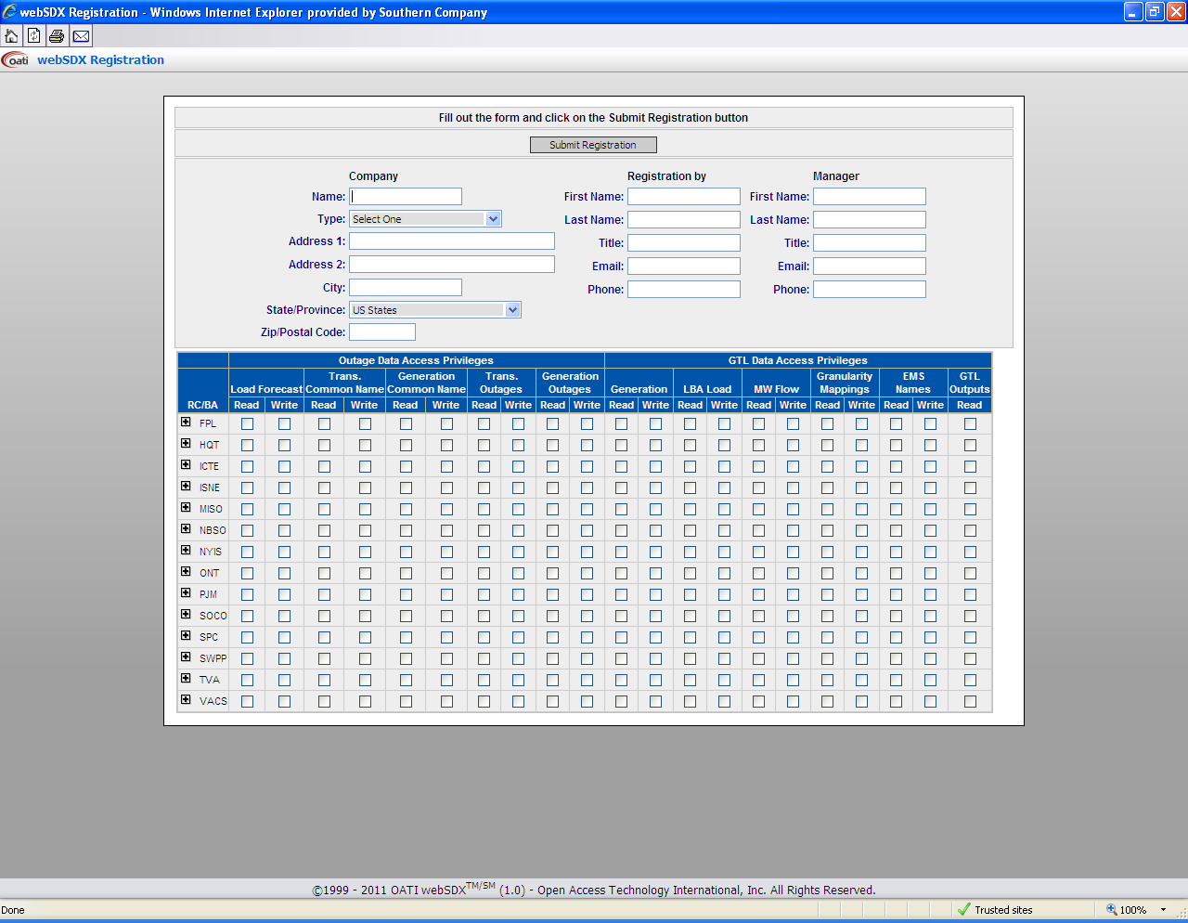

Figure 4.3-1 Sample Company Registration Form

When the registrant submits the request notification e-mails are sent to the appropriate webSDX users and to the registrant. NERC staff forwards the request to the affected Reliability Coordinators for approval or denial. Once the request has been approved by the affected Reliability Coordinators, NERC staff will approve, deny, or approve the request with restrictions that limit the companies privileges to a subset of those requested. Request denial or approval notifications will be forwarded to the registrant by e-mail. Once a company has been approved the OATI help desk will assist the registrant in creating a Company User Administrator.

**PFV project:**

(Generator Priority Determination) As part of the online registration process, each BA will be required to select an option as to how transactions will be treated in its BA in the PFV process: (1) Tag all non-firm, or (2) Generator Prioritization.

Also, each TSP will be required to enter if it has a Coordination Agreement with any other TSP(s).

## 4.3 Company Management

User management and registration for each company is the responsibility of the Company User Administrator. The Company User Administrator can create and remove users, reset passwords, link webCares Client Digital Certificates to users and assign, modify and revoke access and role privileges of individual users. The user administrator must be careful in assigning roles and access permissions so as not to provide confidential data to users that do not have rights to access the data. The Company User Administrator may assign any of the access privileges NERC has granted the company.

Two classes of users will be provided. One for access to the webSDX User Interface (UI-Users) and another to access the webSDX via the web service (WS-Users) for data exchange. WS-Users will not be granted access to the webSDX User Interface. Likewise, UI-Users will not be granted access to the web service.

All user access to the webSDX is controlled by user name, password, and webCARES digital certificate. UI-Users must reset their passwords at the first login into the webSDX, and periodically, at least once every six months. Passwords must comply with strong password rules:

* At least 8-characters long
* Three of four character types
  + Lower case letters
  + Upper case letters
  + Digit (0-9)
  + Special characters such as %, &, $, etc.
* Passwords must not be repeated

WS-User passwords will not expire. Login must still provide webCARES digital certificate for user authentication. The User Administrator may also specify a range of IP addresses from which the WS-User may connect to the webSDX.

## 4.4 Change Time Zones

New user accounts will default to CST. You can select the time zone in which you would like your application to display all dates and time in the system. To change your time zone, select “Change Time Zone” from the left menu after logging in. After selecting the new time zone, click “Save”. The system stores all dates and times in the CST time zone and converts them to the time zone your account specifies.

To keep from having to change the time zone when the time changes from standard time to daylight saving time use the prevailing time (i.e. EPT Eastern Prevailing Time). If Standard Time or Daylight Saving Time are chosen the user must manually change the time zone when time transitions occur.

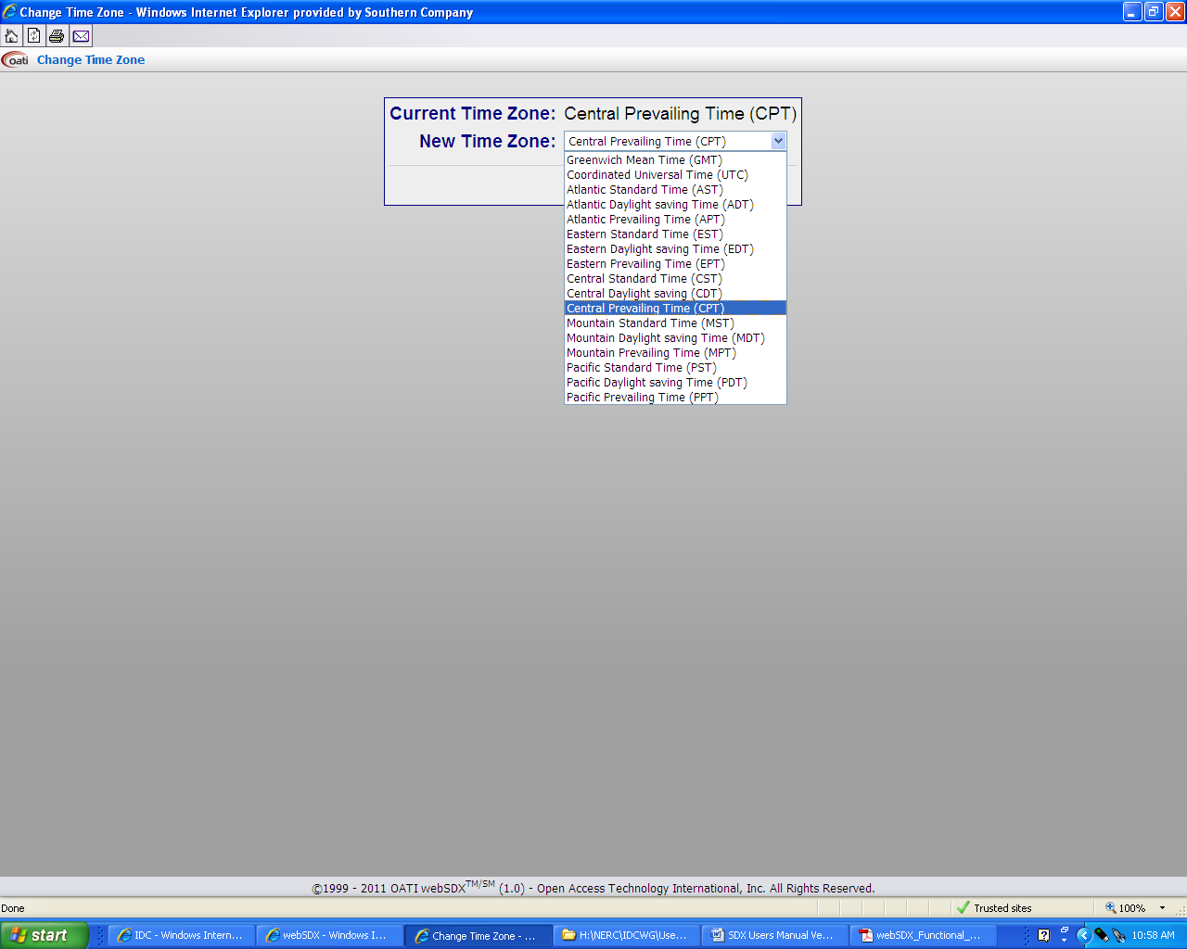

## 4.5 Change Password

In an effort to comply with NERC Cyber Security Standards, users of the System Data Exchange (SDX) tool are required to change passwords on a predetermined timeframe.

* Upon logging into the application for the first time the user is required to change the password.
* Individual User Account passwords must be changed **every six months**.

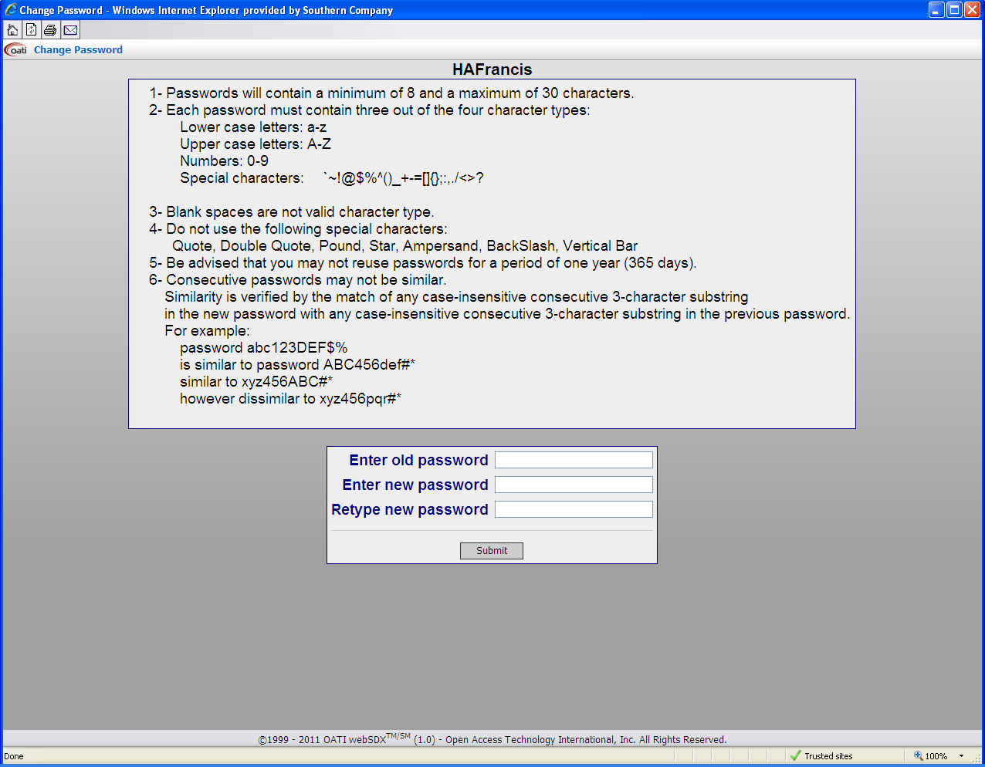

## 4.6 Display Settings

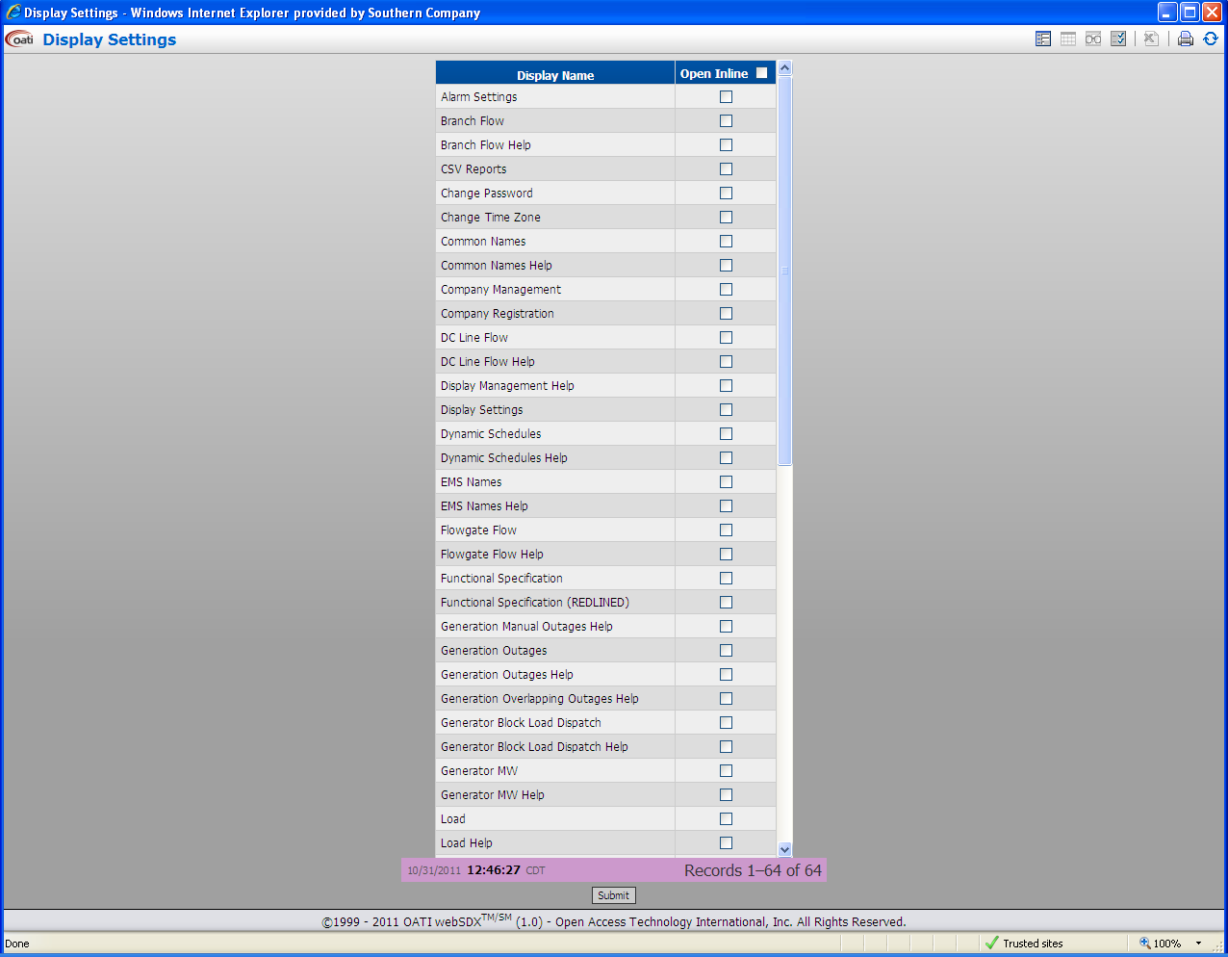

# 5.0 Data

## 5.1 Generator Outages

The Generator Outages display creates a listing of the generator outages loaded in SDX. The display can be filtered based on *RC, BA, Outage Type*, Active *Date*, Pmax Minimum, Pmax Maximum, and Bus/Common Name/MRID.

The Active Date filter option allows the user to search on outages based on the day, week, month, quarterly, or yearly that these outages are active. It also allows the user to go in the past to look at past or future outages.

## 5.2 Transmission Outages

The Transmission Outages display creates a listing of the non-generator transmission element outages loaded in SDX. The display can be filtered based on *RC, BA, From Bus BA, To Bus BA, Tertiary BA, Equipment Type, Outage Type, Active Date, KV Level Minimum, KV Level Maximum, and Bus/Common Name/MRID.*

## 5.3 Load

The Load display creates a listing of the BA load data loaded in SDX. The display can be filtered based on *RC, BA, Date, and Period*. The period filter allows filtering hourly, daily, weekly, and monthly.

## 5.3 Common Names

The Common Names display creates a listing of buses and their associated common names. The display can be filtered based on *RC, BA, From Bus BA, To Bus BA, Tertiary BA, and Equipment Type, Post to RCIS, KV Level Minimum, KV Level Maximum, Pmax Minimum, Pmax Maximum, and Bus/Common Name.* The Post to RCIS allows the user the flexibility to view all outages in SDX, those outages posted to SDX, or those outages not posted to SDX.

# 6.0 GTL Data

GTL data is the data required from the RCs and BAs in order to implement the generator-to-load solution in the IDC. The GTL displays will display data for entities that the user has permission to view.

## 6.1 Generator MW

The Generator MW display creates a listing of the generator information loaded in SDX. The display can be filtered based on *RC, BA, LBA, KV Level Minimum and Maximum, Pmax Minimum and Maximum, and Bus/EMS Name.*

## PFV Project:

(Generator Priority Determination)

## 6.1.1 Generator Service Priority

The Generator Service Priority is the set of data for each generator, entered by the PSE/LSE, BA, or TSP, which specifies the type of service schedule (long term, short term, default) ; and type and amount of service (Firm/non-firm and MW, % of output).

## 6.2 Load Zone MW

The Load Zone MW display creates a listing of the load and interchange data for each load zone modeled in the SDX. The display can be filtered based on *RC, BA, and LBA.*

## 6.3 Flowgate Flow

The Flowgate Flow display creates a listing of the monitored and contingency branch flows for each flowgate modeled in the SDX. The display can be filtered based on *RC, BA, Flowgate, and Bus/EMS Name.*

## 6.4 Branch Flow

The Branch Flow display creates a listing of the flow and modeling data for each branch that is modeled in the SDX. The display can be filtered based on *RC, BA, LBA, Equipment Type, From Bus LBA, To Bus LBA, Tertiary Bus LBA, KV Level Minimum and Maximum, and Bus/EMS Name.*

## 6.5 Tie-Line Flow

The Tie-Line Flow display creates a listing of the flow for each branch that is modeled as a tie-line in the SDX. The display can be filtered based on *RC, LBA, Equipment Type, From Bus LBA, To Bus LBA, Tertiary Bus LBA, KV Level Minimum and Maximum, and Bus/EMS Name.*

## 6.6 Par Flow

The Par Flow display creates a listing of the Par Bank data that is modeled in the SDX. The user can also add and/or edit Par Banks from this display. The display can be filtered based on *RC, BA, and Par Bank/Bus/EMS Name.*

## 6.7 VFT Flow

The VFT Flow display creates a listing of the VFT data that is modeled in the SDX. The display can be filtered based on *RC, BA, From Bus LBA, To Bus LBA, and Bus.*

## 6.8 DC Line Flow

The DC Line Flow display creates a listing of the DC Line data that is modeled in the SDX. The display can be filtered based on *RC, BA, and DC Line/Bus.*

## 6.9 Dynamic Schedules

The Dynamic Schedules display creates a listing of the information for each of the Dynamic Schedules modeled in the SDX. Current and Next Hour information are displayed. The display can be filtered based on *RC and BA.*

## 6.10 Source Granularity

The Source Granularity display shows the source granularity information that is modeled in the SDX. The user can also add, edit or remove Source Granularity from this display. The display can be filtered based on *RC, BA, and Source Granularity.*

## 6.11 Sink Granularity

The Sink Granularity display shows the sink granularity information that is modeled in the SDX. The user can also add, edit or remove Sink Granularity from this display. The display can be filtered based on *RC, BA, and Sink Granularity.*

## 6.12 EMS Names

The EMS Names display shows the EMS Name information for each bus that is modeled in the SDX. The user can edit EMS Name data from this display. The display can be filtered based on *RC, BA, Equipment Type, Bus/From Bus BA, To Bus BA, Tertiary Bus BA, KV Level Minimum and Maximum, Pmax Minimum and Maximum, and Bus/Common Name..*

## 6.13 Generator Block Load Dispatch

The Generator Block Load Dispatch display creates a listing of the block load dispatch data for each generator in SDX. The display can be filtered based on *RC, BA, LBA, Block Load, KV Level Minimum and Maximum, Pmax Minimum and Maximum, and Bus Name.*

# 7.0 Reporting

## 7.1 Upload XML

The Upload XML option allows the user to upload SDX information in XML format. The user must have Web Service privileges in order to use this option.

## 7.2 CSV Reports

The CSV reports allows the user to download SDX information in the .csv format for tools and programs that require information in that format. The reports can be filtered by RC and further filtered by individual BAs.

## 7.3 Transaction Log

The Transaction Log report gives the user a listing of the information being sent to and received from the webSDX. The report shows if data transfers were successful and gives the failure type if a transfer fails. The report can be filtered by Date Range, Transaction Status, Company, and User. Due to the large size of the transactions the data is only saved for 24 hours.

## 7.4 Tie Lines

The Tie Lines report gives the user a list of tie line outages that are loaded in the SDX. The report can be filtered by RC, BA, From Bus BA, To Bus BA, Tertiary Bus BA, Outage Type, Active Date Range, and Bus/Common Name.

## 7.5 Regional Coordination Reports

The Regional Coordination Reports menu allows the user to view pre-defined reports that are used to coordinate outages of common equipment. The reports can be filtered by Report Name, RC, BA, From Bus BA, To Bus BA, Tertiary Bus BA, Equipment Type, Outage Type, Active Date Range, Minimum Pmax, KV Level Minimum and Maximum, and Bus/Common Name.

## 7.6 RCR Configuration

The RCR Configuration is used to create and edit Regional Coordination Reports.

## 7.7 RCR Audit Trail

The RCR Audit Trail feature allows the user to monitor the use of the Regional Coordination Reports. This feature can also be used to add or delete reports. The user can audit by Report, Access Rights, and Equipment. Each audit can be filtered by Date Range, Select Report, and Select Action. The Equipment report can also be filtered by Equipment Name.

# 8.0 Documents

## 8.1 Function Specifications

This is an OATI document that gives detailed information on the use of the SDX tool. The document details the following:

* Web Support of the SDX schema for data upload and download
* webSDX User Interface
* SDX and IDC integration
* NERC RCIS integration
* Registered company data access configuration
* Validating outage uploads with future IDC models

The current version of the functional specifications will be posted on the SDX website. Proposed changes to the specifications will also be posted and designated as (REDLINED).

## 8.2 XSD Schema

This OATI document is available in two versions. The XSD Schema document gives details of the schema in text form. The XSD Schema (Web View) gives the schema details in a web format.

## 8.3 Web Service Validation Warning and Errors

This is a companion document to the functional specifications. This document contains the messages that describe the SDX response to requests that fail business logic validation. The content of this document is repeated in Appendix B Section 6 of this document.

## 8.4 Registration Guide

The registration guide is for use by NERC, OATI, and Company Administrators. The guide defines the process for ensuring the security and confidentiality of the SDX data.

# 9.0 Window

## 9.1 Layouts

Layout is used to either create a Custom layout or to restore the last layout when the system is logged in.

## 9.2 Refresh Menu

Refresh Menu will update the menu bar with the latest menu information.

## 9.3 Close All

Close All will close all open windows in SDX.

## 9.4 Reset Window Locations

This option will close all open windows in SDX and reset the SDX page.

# Appendix A

# Graphic User Interface (GUI)

## A1 Entering Load Data

To enter Load data, select **Load** from the **Data** menu. A list of load data will be displayed based on the last setting of the filters. Each control area will have a link to hourly, daily, weekly, and monthly load entry screens. Load data in the past cannot be modified.

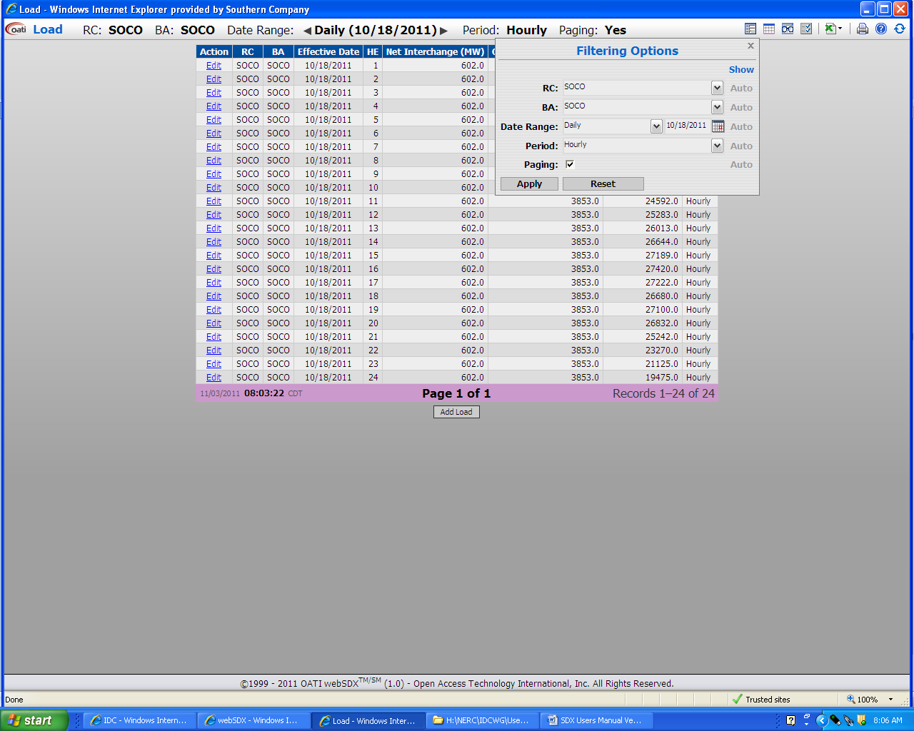

Selecting the desired filter settings will open a window to enter the load data.

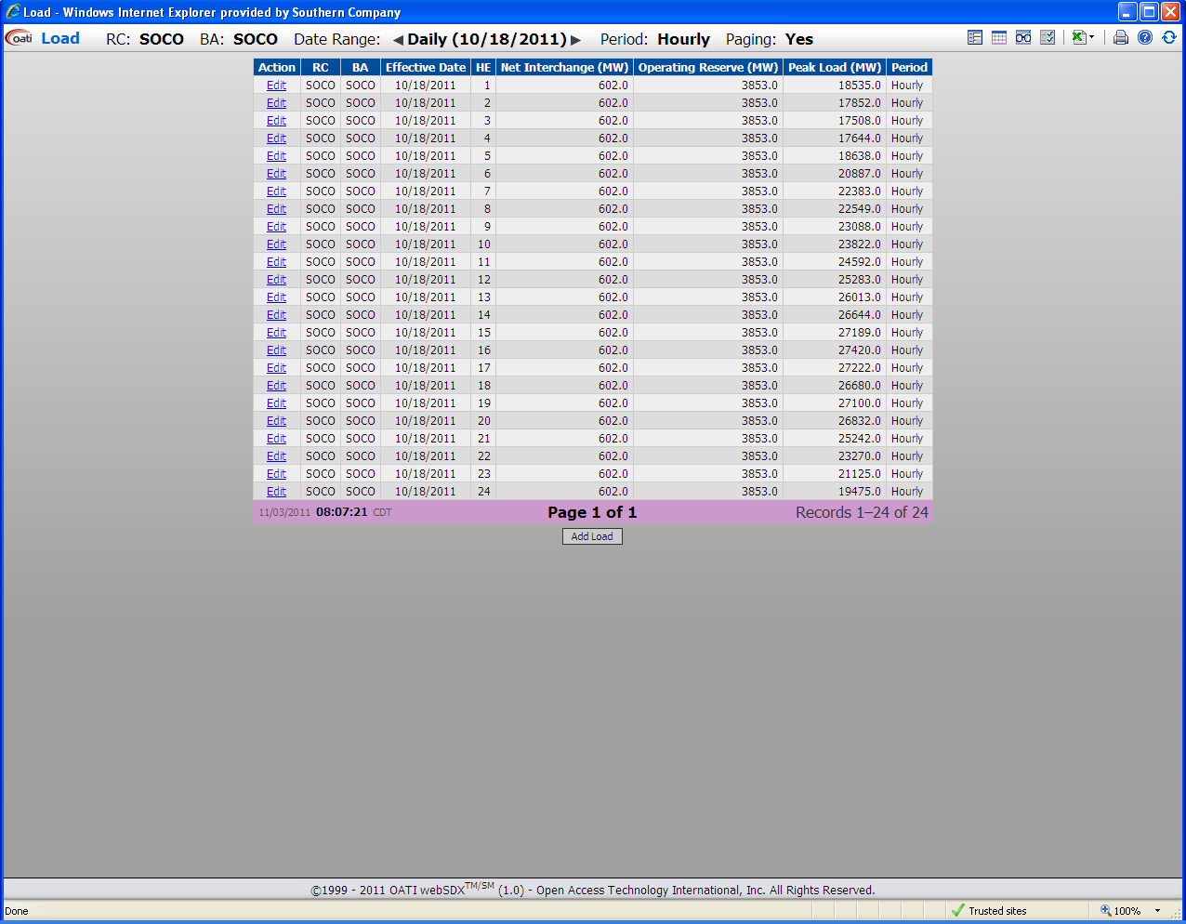

Hourly Load Data may be entered/edited for the current day plus three days into the future. Daily Load Data may be entered/edited for the current day plus twenty seven days into the future. Weekly Load Data may be entered for the current day plus five weeks into the future. Previous weeks in the month will be displayed. However, you will not be allowed to change data that is in the past. Monthly Load Data may be entered for the current month on a rolling one year basis.

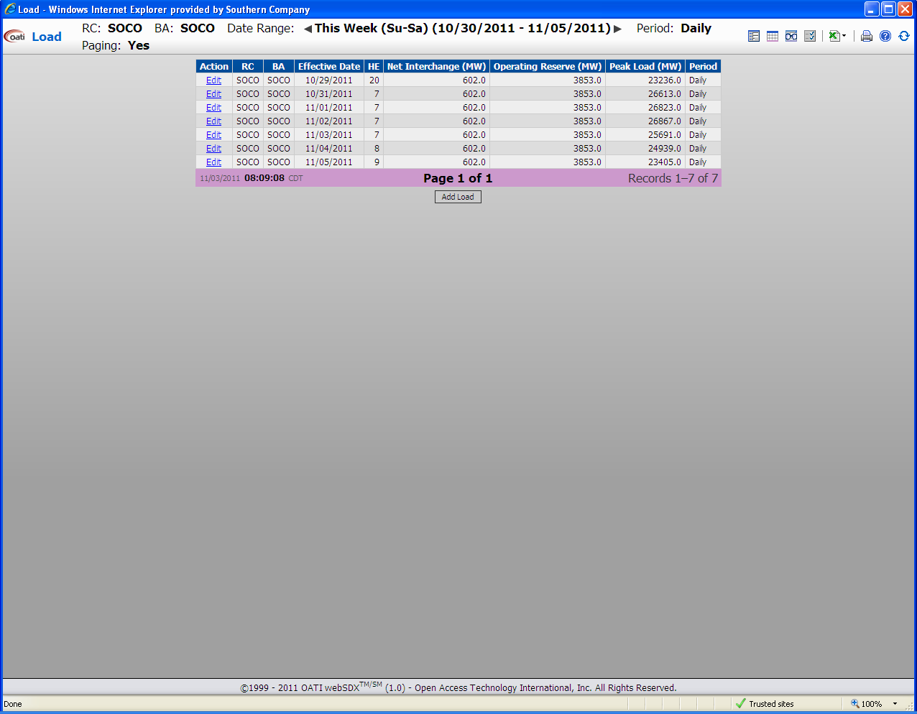

To edit load data that is already in SDX, click on **Edit** in the **Action** column.

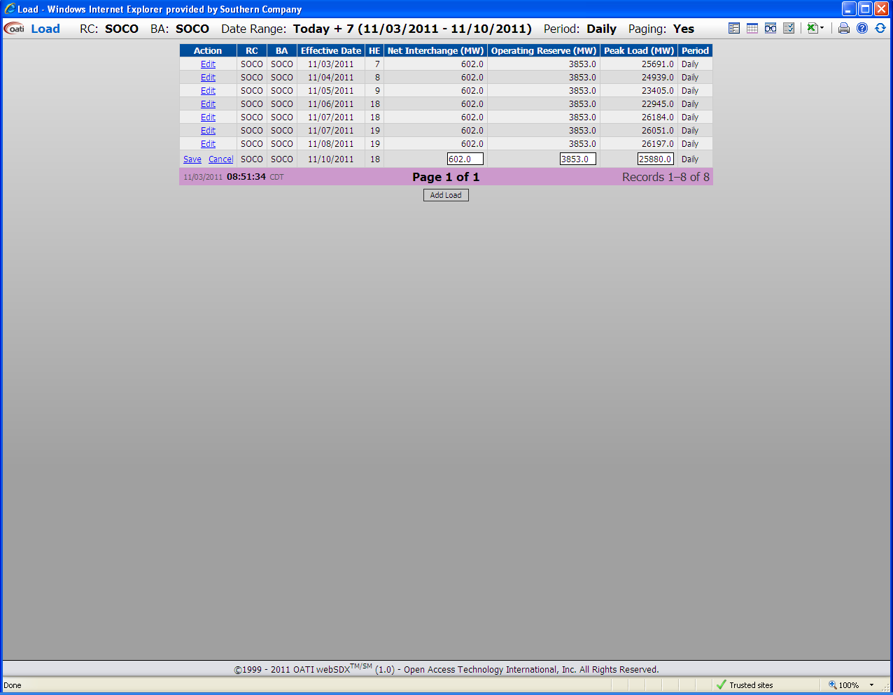

Once the data has been edited click on **Save** in the **Action** column. If the changes are not wanted click **Cancel**.

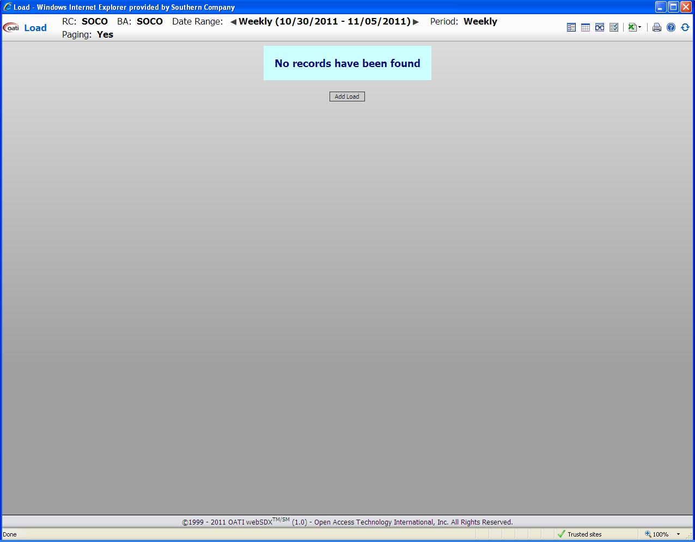

To add load use the **Add Load** control.

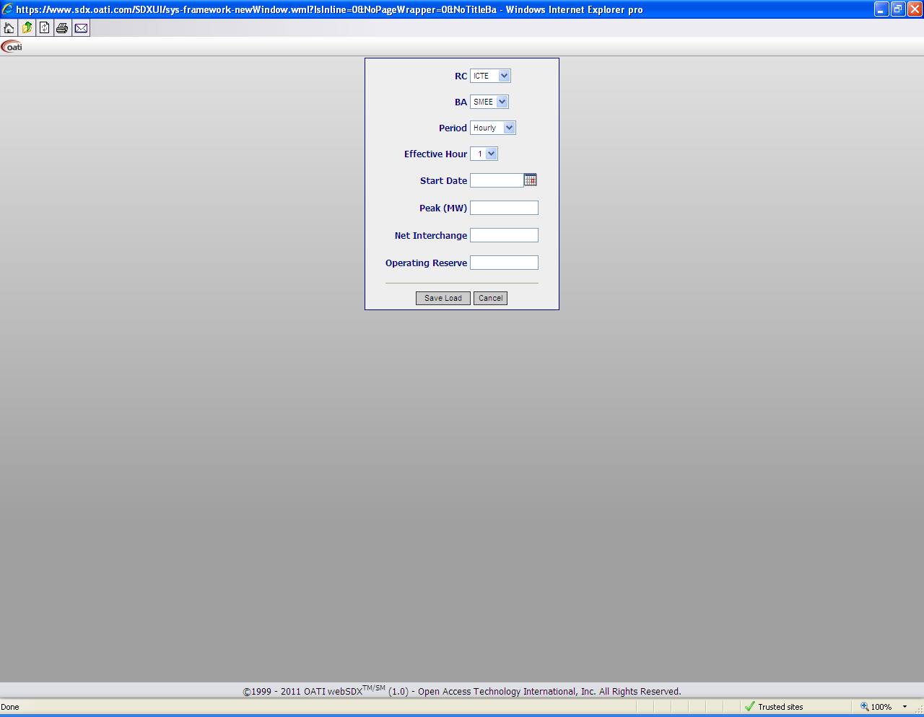

Fill in the appropriate information and click **Save Load**. The user can exit this screen without changes using the **Cancel** control.

## A2 Branch, Generator, and Transformer Outages

To enter an outage, select either Generator Outages or Transmission Outages from the **Data** menu. A listing of outages in SDX will be displayed.

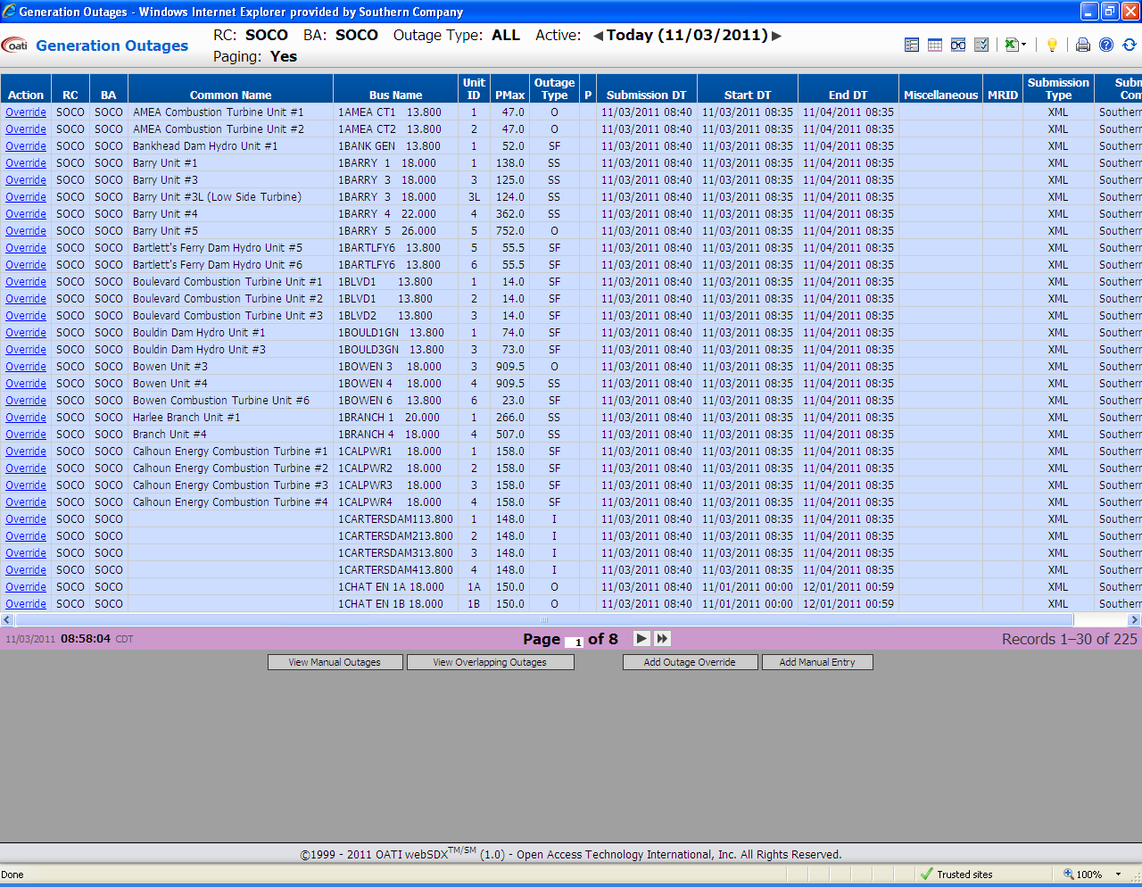

To change an existing outage click on **Override** in the Action column.

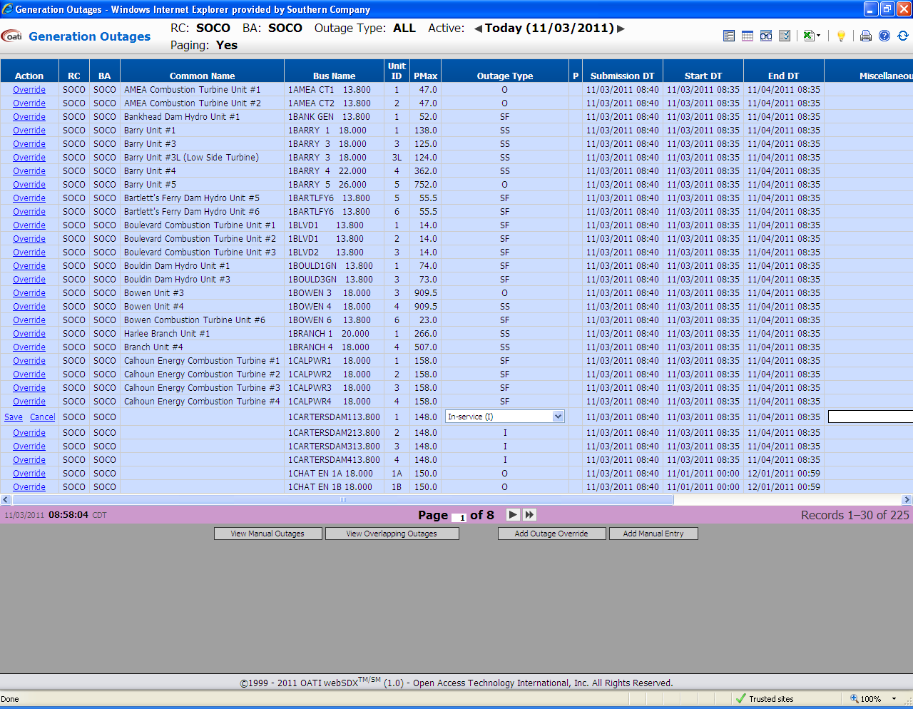

Once the editable data has been changed **Save** the changes. The user can also exit the override option by using **Cancel**.

To add a new outage use the **Add Outage Override** control.

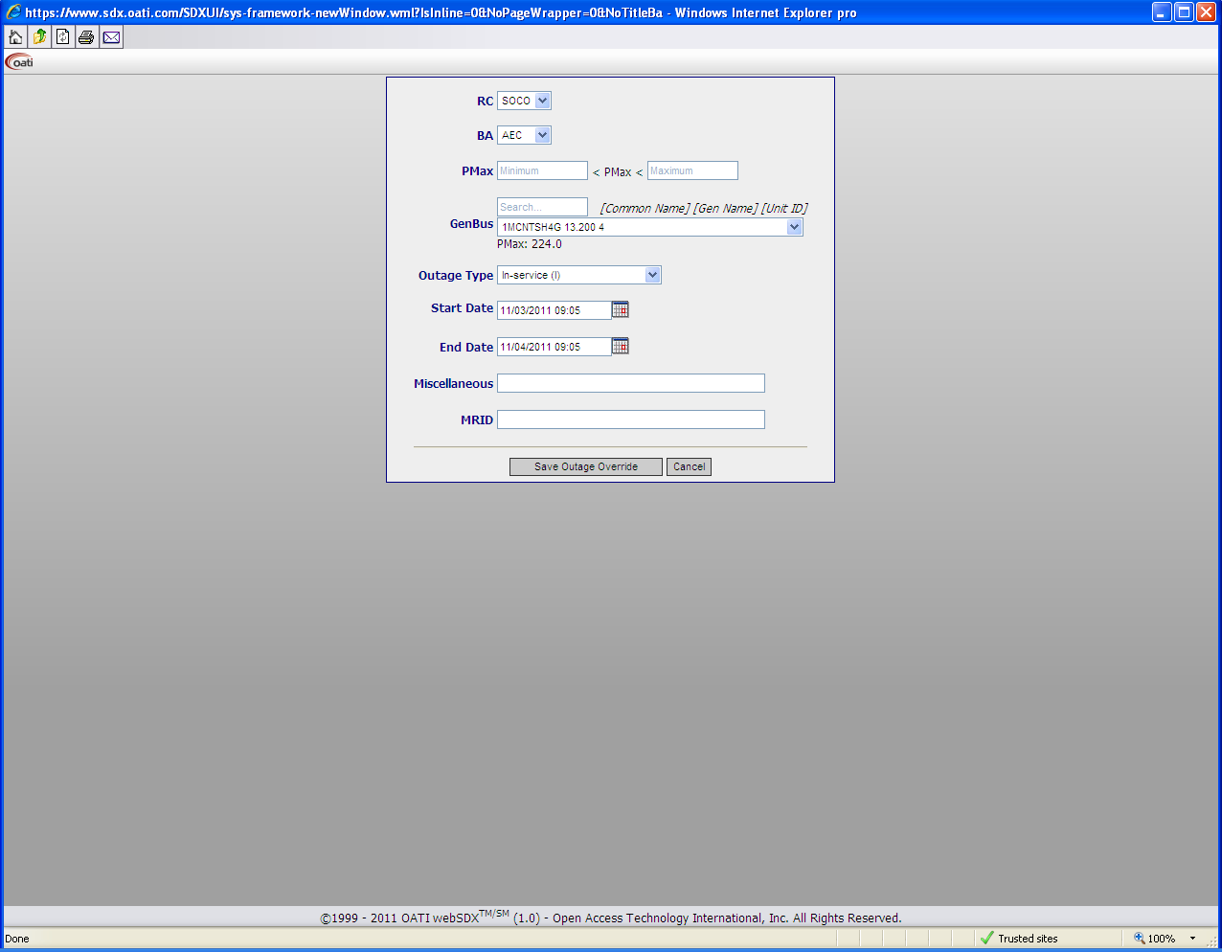

Once the appropriate outage information has been entered use the **Save Outage Override** control to save the new outage. The user can also exit from adding an outage by using **Cancel**.

## A3 Entering/Editing Common Names

Common Names are edited and added using the same process as adding and editing outages. The Common Names interface will display a listing of the transmission elements based on the filter settings. In order to edit or add Common Names use the **Edit** function in the **Action** column.

# Appendix B

# Web Service

## B1 Web Service API

The heart of the webSDX system is an efficient web service that enables automated upload and download of data. In order to access the web services API companies must register a web service user and provide the user with a valid webCARES digital certificate. All web service requests require a valid user name, password, and certificate attached to the HTTPS request.

All data upload requests require the requestor to provide the webSDX indication whether the uploaded data is to be validated and imported into the webSDX, validated against the current webSDX PSS/E base case data model only with no data import, or validated against a future PSS/E base case data model in the Book of Flowgates Database Management System with no data import.

There are two levels of validation performed on the XML file: the schema validations and business rule validations. If any data in the request violates the data definition or XSD validations there will be a schema validation error and the request will not be performed. If no warnings or errors are found in the validation process, the response for the upload will contain the word “success”.

If the data in a ‘Get’ request violates the business rules the results of the request will not be as expected. If the data in a ‘Set’ request violates the business rules described the data will not be uploaded and appropriate error messaging will be provided; however all valid data will be uploaded. Other warning messages may be presented during the business rules validations; however a warning message will not prevent the data from being loaded, and the business rules must be reviewed to understand the message.

## B2 Overlapping outages

There are times when multiple outages are reported for the same equipment and different outage types where the time range of the outages overlaps. These are called overlapping outages. A precedence rule for overlapping outages has been devised for the purpose of reporting one outage type for a specific transmission element at any given time. The priority rule for transmission and generator outages are as follows:

**Transmission Outage Overlaps**

The following priority rule describes the transmission outage overlaps (branch, 2-winding transformer, and 3-winding transformer).

* Priority 1: Manual overwrite – the most recent overwrite takes precedence over all other outages regardless of outage type
* Priority 2: Forced Outage (F)
* Priority 3: In-service (I)
* Priority 4: Out-of-service – scheduled (O)
* Priority 5: In-service and under hot maintenance (HT)

**Generator Outage Overlaps**

The following priority rule describes the generator outage overlaps

* Priority 1: Manual overwrite – the most recent overwrite takes precedence over all other outages regardless of outage type
* Priority 2: Forced Outage (F)
* Priority 3: In-service (I)
* Priority 4: Out-of-service – scheduled (O)
* Priority 5: Out-of-service in short standby mode (SS) – Can be brought on line in >3 hours
* Priority 6: Out-of-service in fast standby mode (SF) - Can be brought on line in 1-2 hours
* Priority 7: In-service and derated (P) – If more than one de-rate exists for a resource, the lowest de-rate MW value takes precedence and becomes the effective de-rate
* Priority 8: Out-of-service in static VAR compensator mode (SVC)
* Priority 9: In-service in pump storage mode (PS)

## B3 Data sent to Reliability Coordinator Information System (RCIS)

A subset of the outages submitted to the SDX are passed on to the RCIS. The outages meeting the following criteria are sent to the RCIS.

* Any data that is marked as PostToRCIS will be passed to the RCIS
* If PostToRCIS data is not provided it will not be passed on to the RCIS if the base kV of the “From” and “To” buses are less than 200kV
* If PostToRCIS data is not provided it will be passed on to the RCIS if the base kV of either the “From” or the “To” buses are greater than 200kV

## B4 Element Descriptions

|  |  |
| --- | --- |
| **Function** | **Description** |
| GetEquipment | Returns a list of equipment (devices) in an RC. This function will return branches, transformers, and generators from an IDC case model. The branch and transformer data returned from this function mimics the PSS/E Raw D file format where:   * Branch: includes branches, tie lines, and 2 winding transformers * Transformer: includes 2 and 3 winding transformers |
| GetLoad | Returns the current Load data for an RC |
| GetRCCurrentOutages | Returns the current output data for an RC, this function is the replacement for the previous FTP output file. The outage data returned from this function is from the current day and into the future. This function returns:   * Daily, Weekly, Monthly, and Hourly Load data * Generator outages * Transformer outages: which includes branches, tie lines, and 2 winding transformer outages * Par tap outage * Element group outages * 3 Winding transformer outages: which includes only 3 winding transformers |
| GetRCList | This function returns a list of the current output RCs |
| GetSystemState | This function returns the outage information for a desired RC on a given date. The client may choose to have one or more of the following device types returned: Branches, Generators, and Transformers.  The data returned from this function is for all outages active during the requested date. The start and end dates provided in the response are those associated with the submitted outage. The branch and transformer data returned from this function mimics the PSS/E Raw D file format where:   * Branch: includes branches, tie lines, and 2 winding transformers * Transformer: includes 2 and 3 winding transformers |
| SetBranchCommonName | This function will update the common name for branches, tie lines, and 2 winding transformers |
| SetBranchOutage | This function will save outages to the SDX database for branches, tie lines, and 2 winding transformers |
| SetGeneratorCommonName | This function will update the common name for generators |
| SetGeneratorOutage | This function will save outages to the SDX database for generators |
| SetLoad | This function will save the load data for an RC to the SDX database |
| SetTransformerCommonName | This function will update the common name for 3 winding transformers |
| SetTransformerOutage | This function will save outages to the SDX database for 3 winding transformers |

## B5 Element Definitions and Required Fields

|  |  |  |  |
| --- | --- | --- | --- |
| Function | Required Fields | Notes | |
| GetEquipment | RC  CA | ShowBranches, ShowGenerators, ShowTransformers, and BusName are optional, but at least one should be supplied. If none of the above are supplied, no data will be returned. | |
| GetLoad | BeginDate  EndDate  TimeInc | RC and CA are optional, but at least one should be supplied. If neither are supplied an error message will be returned. | |
| GetRCCurrentOutages | None | OutputFileID and RC are optional. If neither of these are supplied the function will return the outage information for all RCs. | |
| GetRCList | None |  | |
| GetSystemState | OutageDate | ShowBranches, ShowGenerators, ShowTransformers, are optional, but at least one should be supplied. If none of the above are supplied, no data will be returned. | |
| GetOverlappingAndTieLineReport |  |  | |
| GetOutageOverrides |  |  | |
| SetBranchCommonName | CA  FromBusName  ToBusName  CircuitID | CommonName, and PostToRCIS are optional. | |
| SetBranchOutage | RC  CA  TZ  IBus  JBus  CircuitSeq  BeginDate | An empty BranchRec data set indicates that all outages for RC/BA are to be removed. | |
| SetGeneratorCommonName | CA  BusName  CircuitID | CommonName, and PostToRCIS are optional. | |
| SetGeneratorOutage | RC  CA  TZ  Plant  GeneratorSeq  BeginDate | An empty BranchRec data set indicates that all outages for RC/BA are to be removed. | |
| SetLoad | RC  CA  TZ  TimeInc  EffectiveDate | NetMW, OpResMW, PeakMW, and hour are optional. | |
| SetTransformerCommonName | CA  IBusName  JBusName  KBusName  CircuitID |  | |
| Function | Required Fields | Notes | |
| SetTransformerOutage | RC  CA  TZ  IBus  JBus  KBus  CircuitSeq  BeginDate  OutageType |  | |
| GetEquipmentResponse | IBusID  IBusName  IBaseKV  JBusID  JBusName  JBaseKV  KBusID  KBusName  KBaseKV  CiruitSeq  EquipmentType | I Bus data only required for generators. J Bus data required for branches and 2-winding transformers. K Bus data required for 3-winding transformers. | |
| GetLoadResponse | CA  TimeInc  EffectiveDate | PeakHour is only provided for Hourly and Daily load | |
| GetRCCurrentOutagesResponse | RC  CA  TZ  StartDate  HREnd  Plant  ID  MW  Status  IBus  JBus  ID  Tap  Group | When no outages are present it indicates that no outages are available in the webSDX for the RC/CA.  When multiple outages overlap the outages are split into time intervals according to their start and stop time. | |
| GetRCListResponse | OutputFileID  OutputFileName  Active  RC |  | |
| GetRCCAListResponse | RC  CA |  | |
| GetSystemStateResponse | IBusID  IBusName  IBaseKV  CircuitSeq |  | |
|  |  |  | |
| GetOverlappingAndTieLine ReportResponse | RC  CA  TZ  IBus  JBus  KBus  ID  IBusCA  JBusCA  KBusCA  StartDate  Type  SubmitCA  SubmitType  SubmitDate  SubmitManual Overwrite  Plant  MW  SubmitMW |  | |
| GetOutageOverrideResponse | RC  CA  TZ  Plant  ID  MW  StartDate  Status  IBus  JBus | When no outages are present it indicates that no overrides are available in the webSDX for the RC/CA. | |
| SetBranchCommonName Response | Error |  | |
| SetBranchOutageResponse | Error |  | |
| SetGeneratorCommonName Response | Error |  | |
| SetGeneratorOutageResponse | Error |  | |
| SetLoadResponse | Error |  | |
| SetTransformerCommonName Response | Error |  | |
| SetTransformerOutage Response | Error |  |
|  |  |  | |

## B6 Error Management

|  |  |
| --- | --- |
| Function | Error Message |
| SetBranch CommonName | * Unknown branch [“FromBus Name” – “ToBus Name” – “Circuit”] in CA “CA Name * Multiple common name/RCIS flag for branch [“FromBus Name” – “ToBus Name” – “Circuit”] in CA “CA Name * Invalid user privilege for CA: “CA Name” * Invalid CA “CA Name” |
| SetBranch Outage | * Unknown branch [“IBus” – “JBus” – “CircuitSeq”] in CA “CA Name” * KBus not permitted for [“IBus” – “JBus” – “CircuitSeq”] in CA “CA Name” * Invalid outage type for [“IBus” – “JBus” – “CircuitSeq”] in CA “CA Name” * Invalid EndDate < BeginDate for [“IBus” – “JBus” – “CircuitSeq”] in CA “CA Name” * Invalid EndDate in the past for [“IBus” – “JBus” – “CircuitSeq”] in CA “CA Name” * WARNING: Overlapping outage for [“IBus” – “JBus” – “CircuitSeq”] in CA “CA Name” * WARNING: Overlapping XML/Manual outage for [“IBus” – “JBus” – “CircuitSeq”] in CA “CA Name” * Invalid RC-BA relationship for RC “RC Name” – BA “BA Name” * Invalid time zone “Time Zone” for RC “RC Name” – BA “BA Name” * Multiple record sets for RC “RC Name” – BA “BA Name” * Invalid user privilege for BA “BA Name” |
| SetGenerator CommonName | * Invalid user privilege for CA “CA Name” * Invalid CA “CA Name” * Unknown generator [“BusName” – “CircuitID”] in CA “CA Name” * Multiple common name/RCIS flag for Generator [“BusName” – “CircuitID”] in CA “CA Name |
| SetGenerator Outage | * Unknown generator [“Plant” – “GeneratorSeq”] in CA “CA Name” * Invalid negative MW for [“Plant” – “GeneratorSeq”] in CA “CA Name” * Invalid outage type for [“Plant” – “GeneratorSeq”] in CA “CA Name” * Invalid EndDate < BeginDate for [“Plant” – “GeneratorSeq”] in CA “CA Name” * Invalid EndDate in the past for [“Plant” – “GeneratorSeq”] in CA “CA Name” * WARNING: Overlapping outage for [“Plant” – “GeneratorSeq”] in CA “CA Name” * WARNING: Overlapping XML/Manual outage for [“Plant” – “GeneratorSeq”] in CA “CA Name” * Invalid RC-BA relationship for RC “RC Name” – BA “BA Name” * Invalid time zone “Time Zone” for RC “RC Name” – BA “BA Name” * Multiple record sets for RC “RC Name” – BA “BA Name” * Invalid user privilege for BA “BA Name” |
| SetLoad | * Negative daily load in CA “CA Name” on “Effective Date” * Negative hourly load in CA “CA Name” on “Effective Date” HE: “Hour Ending” * Negative monthly load in CA “CA Name” on “Effective Date” * Negative weekly load in CA “CA Name” on “Effective Date” * Invalid RC-BA relationship for RC “RC Name” – BA “BA Name” * Invalid time zone “Time Zone” for RC “RC Name” – BA “BA Name” * Multiple record sets for RC “RC Name” – BA “BA Name” * Invalid user privilege for BA “BA Name” |
| SetTransformer CommonName | * Invalid user privilege for CA “CA Name” * Invalid CA “CA Name” * Unknown 2-W transformer [“IBus Name” – “JBus Name” – “CircuitID”] in CA “CA Name” * Unknown 3-W transformer [“IBus Name” – “JBus Name” – “KBus Name” – “CircuitID”] in CA “CA Name” * Multiple common name/RCIS flag for 2-W transformer [“IBus Name” – “JBus Name” – “CircuitID”] in CA “CA Name” * Multiple common name/RCIS flag for 3-W transformer [“IBus Name” – “JBus Name” – “KBus Name” – “CircuitID”] in CA “CA Name” |
| SetTransformer Outage | * Unknown transformer [“IBus” – “JBus” – “KBus” - “CircuitSeq”] in CA “CA Name” * Invalid outage type for [“IBus” – “JBus” – “KBus” - “CircuitSeq”] in CA “CA Name” * Invalid EndDate < BeginDate for [“IBus” – “JBus” – “KBus” - “CircuitSeq”] in CA “CA Name” * Invalid EndDate in the past for [“IBus” – “JBus” – “KBus” - “CircuitSeq”] in CA “CA Name” * WARNING: Overlapping outage for [“IBus” – “JBus” – “KBus” - “CircuitSeq”] in CA “CA Name” * WARNING: Overlapping XML/Manual outage for [“IBus” – “JBus” – “KBus” - “CircuitSeq”] in CA “CA Name” * Invalid RC-BA relationship for RC “RC Name” – BA “BA Name” * Invalid time zone “Time Zone” for RC “RC Name” – BA “BA Name” * Multiple record sets for RC “RC Name” – BA “BA Name” * Invalid user privilege for BA “BA Name” |

**Notes:**

All webService XML requests are validated against the SDX XSD schema.

XML validation errors will result in the rejection of the entire payload. No business logic validation will be performed.

XML validation error messages will contain error details and error location in the XML payload.

The messages in the table above are potential responses to business logic validation.

Double quotes are used to refer to words that vary based on the input.

# Appendix C

# Web Service for Generator-to-Load

## C1 Web Methods for Generator-to-Load

The Generator-to-Load web method will decompress the input before processing it and compress the response. The compressed data format will be the GZIP data format. The input and the output of the SendCompressedData method will be the base 64 encoded string representing the compressed data.

## C2.0 Upload Web Methods

## C2.1 Element Descriptions

|  |  |
| --- | --- |
| **Function** | **Description** |
| GTLSetGeneratorMW | Setting the Generator MW current and next-hour output value for any given generator as defined in the model |
| GTLSetGeneratorMW Response | This returns the response of the request |
| GTLSetLoadZoneMW | Setting the Load Zone MW current and next-hour values for any given defined Load Zone in the model |
| GTLSetLoadZoneMW Response | This returns the response of the request. |
| GTLSetBranchFlow | Setting the real time branch flows for those elements associated with Tie Line and or Flowgate. |
| GTLSetBranchFlow Response | This returns the response of the request. |
| GTLSetTieLineFlow | Setting the real time tie line flows for those elements associate with a Tie Line as defined in the model. |
| GTLSetTieLineFlow Response | This returns the response of the request. |
| GTLSetParTap | Setting the PAR Tap positioning for any given defined PAR in the model. |
| GTLSetParTapResponse | This returns the response of the request. |
| GTLSetVFT | Setting the real time VFT flow for any given defined VFT in the model. |
| GTLSetVFTResponse | This returns the response of the request. |
| GTLSetDCLines | Setting the real time flow on any given DC Lines or Tie as defined in the model. |
| GTLSetDCLinesResponse | This returns the response of the request. |
| GTLSetDynamicSchedules | Setting the MW active schedule on a given dynamic schedule. |
| GTLSetDynamicSchedules Response | This returns the response of the request. |
| GTLSetSourceGranularity | Setting the mapping for a specific Source and its NERC Registry source point. |
| GTLSetSourceGranularity Response | This returns the response of the request. |
| GTLSetSinkGranularity | Setting the mapping for a specific Sink and its NERC Registry source point. |
| GTLSetSinkGranularity Response | This returns the response of the request. |
| GTLRemoveGranularity | Removes any Source and/or Sink granularity currently in place. |
| GTLRemoveGranularity Response | This returns the response of the request. |
| GTLSetEMSPSSEMapping | Setting the mapping between EMS and PSSe for given elements. |
| GTLSetEMSPSSEMapping Response | This returns the response of the request. |
| GTLRemoveEMSPSSE  Mapping | Removes any mapping between EMS and PSSe as previously provided. |
| GTLRemoveEMSPSSE  MappingResponse | This returns the response of the request. |
| GTLSetGeneratorBlock LoadDispatch | Setting the order of generator dispatch in blocks within an entity. |
| GTLSetGeneratorBlock LoadDispatchResponse | This returns the response of the request. |

## C2.2 Element Definitions and Required Fields

|  |  |  |
| --- | --- | --- |
| Function | Required Fields | Notes |
| GTLSetGeneratorMW | RC  BA  EffectiveTime  TimeZone  Hour  InterchangeBA  Name  TotalMW  LBA  Name  TotalMW  Generator  BusName  MachineID  MW  MaxMW  MinMW  Priority  Pct |  |
| GTLSetGeneratorMWResponse | ErrorList  Error |  |
| GTLSetLoadZoneMW | RC  BA  EffectiveTime  TimeZone  Hour  InterchangeBA  Name  TotalMW  NetSchedule  LBA  Name  TotalMW  LoadZone  Name  LoadMW |  |
| GTLSetLoadZoneMWResponse | ErrorList  Error |  |
| GTLSetBranchFlow | RC  BA  EffectiveTime  TimeZone  LBA  Name  Branch  FromLBA  ToLBA  FromBus  ToBus  Circuit  FROM_TO_MW |  |
| GTLSetBranchFlowResponse | ErrorList  Error |  |
| GTLSetTieLineFlow | RC  BA  EffectiveTime  TimeZone  TieLine  FromLBA  ToLBA  FromBus  ToBus  Circuit  FROM_TO_MW |  |
| GTLSetTieLineFlowResponse | ErrorList  Error |  |
| GTLSetParTap | RC  BA  EffectiveTime  TimeZone  ParBank  Name  PAR  FromLBA  ToLBA  FromBus  ToBus  Circuit  MW  Tap |  |
| GTLSetParTapResponse | ErrorList  Error |  |
| GTLSetVFT | RC  BA  EffectiveTime  TimeZone  VFT  FromBusLBA  ToBusLBA  FromBus  ToBus  MW |  |
| GTLSetVFTResponse | ErrorList  Error |  |
| GTLSetDCLines | RC  BA  EffectiveTime  TimeZone  DCLine  DCLineID  RectifierLBA  InverterLBA  RectifierBus  InverterBus  MW |  |
| GTLSetDCLinesResponse | ErrorList  Error |  |
| GTLSetDynamicSchedules | RC  BA  ScheduleList  Tag  TagID  ReferenceID  SourceBA  SinkBA  CurrentPriority  NextHourPriority  MeasurementSide  CurrentMW  NextHourMW |  |
| GTLSetDynamicSchedules Response | ErrorList  Error |  |
| GTLSetSourceGranularity | RC  BA  EffectiveTime  TimeZone  SourceGranularity  Name  NERCRegistry SourcePoint  PointName  BA  PSE  PSSEBus  LBA |  |
| GTLSetSourceGranularity Response | ErrorList  Error |  |
| GTLSetSinkGranularity | RC  BA  EffectiveTime  TimeZone  SinkGranularity  Name  NERCRegistrySinkPoint  PointName  BA  PSE |  |
| GTLSetSinkGranularity Response | ErrorList  Error |  |
| GTLRemoveGranularity | RC  BA  EffectiveTime  TimeZone  Granularity  Type  Name |  |
| GTLRemoveGranularity Response | ErrorList  Error |  |
| GTLSetEMSPSSEMapping | RC  BA  EffectiveTime  TimeZone  Mapping  Branch  EMSName  PSSEFromLBA  PSSEToLBA  PSSEFromBus  PSSEToBus  PSSECircuit  Generator  EMSName  PSSELBA  PSSEBus  PSSEMachineID |  |
| GTLSetEMSPSSEMapping Response | ErrorList  Error |  |
| GTLRemoveEMSPSSEMapping | RC  BA  EffectiveTime  TimeZone  Mapping |  |
| GTLRemoveEMSPSSEMapping Response | ErrorList  Error |  |
| GTLSetGeneratorBlockLoad Dispatch | RC  BA  EffectiveTime  TimeZone  Generator  BusName  MachineID  BlockLoading  Priority  MW |  |
| GTLSetGeneratorBlockLoad DispatchResponse | ErrorList  Error |  |

* **A “new” WebMethod will be created by OATI where an entity can submit the priority of the unit accompanied by the appropriate MW under that priority. The option of uploading this value as a percentage, in which case no MW value is necessary, should remain. Certain resources may have multiple PSE/LSEs that need to submit priority for them (i.e. Pseudo Tie scenario), in which case IDC will be changed to look at the priority submitted and consider the effective one depending on the issuing TLR entity and the location of the congestion. The option for a TSP, BA, or PSE to submit generator priorities on behalf of a LSE should also be available. TSPs will have approval rights on the Generator Priority determination.**

## C3.0 Download Web Methods

## C3.1 Element Descriptions

|  |  |
| --- | --- |
| **Function** | **Description** |
| GTLGetGenerationTo LoadImpact | Returns the calculated Gen-To-Load Impact on any given defined flowgate in the Book of Flowgate. |
| GTLGetGenerationTo LoadImpactResponse | This returns the response of the request. |
| GTLGetGeneratorMW | Returns the submitted the Generator MW by any given entity on a generator. |
| GTLGetGeneratorMW Response | This returns the response of the request. |
| GTLGetLoadZoneMW | Returns the submitted the Load Zone by any given entity on a zone as defined in the Book of Flowgate |
| GTLGetLoadZoneMW Response | This returns the response of the request. |
| GetFlowgateFlow | Returns the the calculated Flowgate Flow on any given defined flowgate in the Book of Flowgate |
| GetFlowgateFlow Response | This returns the response of the request. |
| GTLGetFlowgateFlow Forecast | Returns the the calculated projected calculated Flowgate Flow on any given defined flowgate in the Book of Flowgate |
| GTLGetFlowgateFlow ForecastResponse | This returns the response of the request. |
| GTLGetBranchFlow | Returns the submitted the Real Time Tie Line and Flowgate elements flows as submitted by any given entity. |
| GTLGetBranchFlow Response | This returns the response of the request. |
| GTLGetBranchFlow Forecast | Returns the submitted or calculated projected Tie Line and Flowgate elements flows. |
| GTLGetBranchFlow ForecastResponse | This returns the response of the request. |
| GTLGetParTap | Returns the effective PAR TAP positioning and Real Time flow on any given PAR as defined in the model |
| GTLGetParTapResponse | This returns the response of the request. |
| GTLGetVFT | Returns the effective VFT TAP positioning and Real Time flow on any given VFT as defined in the model |
| GTLGetVFTResponse | This returns the response of the request. |
| GTLGetDCLines | Returns the Real Time flow on any given and defined DC Line as defined in the model |
| GTLGetDCLinesResponse | This returns the response of the request. |
| GTLGetDynamicSchedules | Returns the MW profile on a given dynamic schedule as submitted by an entity. |
| GTLGetDynamicSchedules Response | This returns the response of the request. |
| GTLGetSourceGranularity | Returns the mapping between a source and its defined mapping to PSE, BA associated with the source as defined in the NERC registery Source/Sink mapping |
| GTLGetSourceGranularity Response | This returns the response of the request. |
| GTLGetSinkGranularity | Returns the mapping between a sink and its defined mapping to PSE, BA associated with the source as defined in the NERC registery Source/Sink mapping |
| GTLGetSinkGranularity Response | This returns the response of the request. |
| GTLGetEMSPSSEMapping | Returns mapping between EMS and PSSe elements as submitted by any given entity. |
| GTLGetEMSPSSEMapping Response | This returns the response of the request. |
| GTLGetGeneratorBlock LoadDispatch | Returns the generator block load dispatch order as submitted by any given entity. |
| GTLGetGeneratorBlock LoadDispatchResponse | This returns the response of the request. |
| GTLGetTieAndFlowgate BranchList | Returns the list of branches that are associated with either a Tie Line or a Flowgate element that require Real Time Flow submission by the owning entity |
| GTLGetTieAndFlowgate BranchListResponse | This returns the response of the request. |

* **An appropriate Get Method is also needed to pull the Generator MW Priorities submitted by any given PSE, LSE, BA, or TSP.**

## C3.2 Element Definitions and Required Fields

|  |  |  |
| --- | --- | --- |
| Function | Required Fields | Notes |
| GTLGetGenerationToLoad Impact | TotalsOnly | RC, BA, and TP are choices |
| GTLGetGenerationToLoad ImpactResponse | EffectiveTime  Threshold  LBA  Flowgate  GTLTotal  CH_TotalForMW  CH_ThresholdForMW  CH_TotalRevMW  CH_ThresholdRevMW  NH_TotalForMW  NH_ThresholdForMW  NH_TotalRevMW  NH_ThresholdRevMW  PriorityLevel |  |
| GTLGetGeneratorMW | RC  InterchangeBA  Hour |  |
| GTLGetGeneratorMWResponse | RC  BA  EffectiveTime  InterchangeBA  Name  TotalMW  LBA  Name  TotalMW  Generator  BusName  MachineID  MW  Priority  MW  Pct |  |
| GTLGetLoadZoneMW | Hour | RC and InterchangeBA are choices |
| GTLGetLoadZoneMWResponse | EffectiveTime  Hour  RC  RCName  InterchangeBA  Name  TotalMW  NetActual  NetSchedule  LBA  Name  TotalMW  LoadZone  Name  LoadMW |  |
| GTLGetFlowgateFlow |  | RC, BA, and TP are choices |
| GTLGetFlowgateFlowResponse | Flowgate  FlowgateID  FlowgateName  PreContingency Flow  MonitoredBranch  FromLBA  ToLBA  FromBus  ToBus  Circuit  PreContingency MW  Submitting Company  FROM_TO_MW |  |
| GTLGetFlowgateFlowForecast |  | RC, BA, and TP are choices |
| GTLGetFlowgateFlowForecast Response | EffectiveTime  Flowgate  FlowgateID  FlowgateName  Forecast  ForecastTime  PreContingency Flow  MonitoredBranch  FromLBA  ToLBA  FromBus  ToBus  Circuit  PreContingency MW  PostContingency MW  FROM_TO_MW |  |
| GTLGetBranchFlow | RC |  |
| GTLGetBranchFlowResponse | EffectiveTime  Branch  FromLBA  ToLBA  FromBus  ToBus  Circuit  FROM_TO_MW  Type  FlowgateID  ElementType  SubmittingCompany |  |
| GTLGetBranchFlowForecast | RC |  |
| GTLGetBranchFlowForecast Response | EffectiveTime  Branch  FromLBA  ToLBA  FromBus  ToBus  Circuit  Forecast  ForecastTime  FROM_TO_MW |  |
| GTLGetParTap | RC  BA |  |
| GTLGetParTapResponse | RC  BA  EffectiveTime  Name  SubmittingCompany  PAR  FromBusLBA  ToBusLBA  FromBus  ToBus  Circuit  MW  Tap |  |
| GTLGetVFT | RC  BA |  |
| GTLGetVFTResponse | RC  BA  EffectiveTime  VFT  FromBusLBA  ToBusLBA  FromBus  ToBus  SubmittingCompany |  |
| GTLGetDCLines | RC  BA |  |
| GTLGetDCLinesResponse | RC  BA  EffectiveTime  DCLine  DCLineID  RectifierBusLBA  InverterBusLBA  RectifierBus  InverterBus  MW  SubmittingCompany |  |
| GTLGetDynamicSchedules | RC  StartTime  EndTime |  |
| GTLGetDynamicSchedules Response | RC  BA  ScheduleList  TimeOfSubmission  Tag  TagID  ReferenceID  NERCRegistry SourceBA  NERCRegistry SinkBA  CurrentPriority  NextHourPriority  MeasurementSide  CurrentMW  NextHourMW |  |
| GTLGetSourceGranularity | RC  BA |  |
| GTLGetSourceGranularity Response | RC  BA  EffectiveTime  SourceGranularity  Name  NERCRegistry  SourcePoint  PointName  BA  PSE  PSSEBus  LBA |  |
| GTLGetSinkGranularity | RC  BA |  |
| GTLGetSinkGranularity Response | RC  BA  EffectiveTime  SinkGranularity  Name  NERCRegistry  SinkPoint  PointName  BA  PSE  PSSEBus  LBA |  |
| GTLGetEMSPSSEMapping | RC  BA |  |
| GTLGetEMSPSSEMapping Response | RC  BA  EffectiveTime  Mapping  Branch  EMSName  PSEEFromLBA  PSSEToLBA  PSSEFromBus  PSSEToBus  PSSECircuit  Generator  EMSName  PSSELBA  PSSEBus  PSSEMachineID |  |
| GTLGetGeneratorBlock LoadDispatch | RC  BA |  |
| GTLGetGeneratorBlock LoadDispatchResponse | RC  BA  EffectiveTime  Generator  BusName  MachineID  BlockLoading  Priority  MW |  |
| GTLGetTieAndFlowgate BranchList | RC  BA |  |
| GTLGetTieAndFlowgate BranchListResponse | Name  Branch  EMSName  PSEEFromLBA  PSSEToLBA  PSSEFromBus  PSSEToBus  PSSECircuit  Type  FlowgateID  ElementType |  |

## C4 Warnings and Errors

|  |  |
| --- | --- |
| Function | Error Message |
| GTLSetBranch Flow | * Warning: duplicate records have been submitted for LBA [“LBA Name”] in BA [“BA Name”]. Only one record was inserted. * Error: LBA [“LBA Name”] is not a valid LBA in BA [“BA Name”] * There is a submission with a more recent effective time, that is not in the future, for LBA [“LBA Name”] in BA “BA Name”. No data for this LBA was inserted. * Unknown branch [(“FromLBA Name”) “FromBus Name” – (“ToLBA Name”) “ToBus Name” – (“TertiaryLBA Name”) “TertiaryBus Name” – “Circuit”] in LBA “LBA Name” * Unknown EMS branch name [“EMS Name”] in BA “BA Name” * Warning: duplicate records with the same information have been submitted for monitored branch [(“FromLBA Name”) “FromBus Name” – (“ToLBA Name”) “ToBus Name” – (“TertiaryLBA Name”) “TertiaryBus Name” – “Circuit”]. All but one of the duplicates were removed. * Conflicting records submitted for branch [(“FromLBA Name”) “FromBus Name” – (“ToLBA Name”) “ToBus Name” – (“TertiaryLBA Name”) “TertiaryBus Name” – “Circuit”]. No records marked as a duplicate were inserted. * Warning: Primary/Backup measurement not defined for tie line [(“FromLBA Name”) “FromBus Name” – (“ToLBA Name”) “ToBus Name” – (“TertiaryLBA Name”) “TertiaryBus Name” – “Circuit”]. Measurement is assumed Primary. * Error: LBA [“LBA Name”] has no rights to update branch [(“FromLBA Name”) “FromBus Name” – (“ToLBA Name”) “ToBus Name” – (“TertiaryLBA Name”) “TertiaryBus Name” – “Circuit”]. Branch flow not inserted. * Warning: The Status element was ignored for branch [(“FromLBA Name”) “FromBus Name” – (“ToLBA Name”) “ToBus Name” – (“TertiaryLBA Name”) “TertiaryBus Name” – “Circuit”]. The Status element is only required for tie lines. * Invalid RC-BA relationship for RC “RC Name” – BA “BA Name” * Invalid time zone “Time Zone” for RC “RC Name” – BA “BA Name” * Multiple record sets for RC “RC Name” – BA “BA Name” * Invalid user privilege for BA “BA Name” |
| GTLSet GeneratorMW | * Warning: duplicate records with the same information have been submitted for Generator [“Bus” – “MachineID”] for LBA [“LBA Name”] in priority [“Priority”]. All but one of the duplicates were removed. * Conflicting records submitted for Generator [“Bus” – “MachineID”] for LBA [“LBA Name”] in priority [“Priority”]. No records marked as duplicate were inserted. * Warning: Sum of MW priorities doesn’t match the generator MW for Generator [“Bus” – “MachineID”] for LBA [“LBA Name”]. MW priorities will be scaled accordingly for GTL calculations. * Warning: Sum of Pct priorities doesn’t equal 100 for Generator [“Bus” – “MachineID”] for LBA [“LBA Name”]. Pct priorities will be scaled accordingly for GTL calculations. * Unknown LBA [“LBA Name”] in Balancing Authority “BA Name” * Warning: duplicate records with the same information have been submitted for LBA [“LBA Name”] in BA “BA Name”. All but one of the duplicates were removed. * Multiple records with conflicting information submitted for LBA [“LBA Name”] in BA “BA Name”. No records were inserted. * Invalid RC-BA relationship for RC “RC Name” – BA “BA Name” * Invalid time zone “Time Zone” for RC “RC Name” – BA “BA Name” * Multiple record sets for RC “RC Name” – BA “BA Name” * Invalid user privilege for BA “BA Name” * Unknown Balancing Authority [“BA Name”] * Warning: duplicate records with the same information have been submitted for InterchangeBA [“Interchange BA”] in BA “BA Name”. Ne records were inserted. * Multiple records with conflicting information submitted for InterchangeBA [“Interchange BA”] in BA “BA Name”. Ne records were inserted. * There is a submission with a more recent effective time, that is not in the future, for InterchangeBA [“Interchange BA”] in BA “BA Name”. No data for this InterchangeBA was inserted. * Unknown EMS Name [“EMS Name”] in BA “BA Name” * Multiple records submitted for Generator [“Bus” – “MachineID”] in BA “BA Name” * Warning: MW<MinMW for [“Bus” – “MachineID”] in BA “BA Name”. MinMW reset to MW. * Warning: MW>MaxMW for [“Bus” – “MachineID”] in BA “BA Name”. MaxMW reset to MW. * Warning: duplicate records with the same information have been submitted for Generator [“Bus” – “MachineID”] in BA “BA Name”. All but one of the duplicates were removed. |
| GTLSetLoad ZoneMW | * Warning: duplicate records with the same information have been submitted for LZ “Load Zone”. All but one of the duplicates were removed. * Conflicting records submitted for LZ “Load Zone”. No records marked as a duplicate were inserted. * Invalid Load Zone “Load Zone” reported for LBA [“LBA Name”] * Load Zone “Load Zone” is not a member of LBA [“LBA Name”] * Balancing Authority [“BA Name”] at Hour [“Hour”] has missing LBAs/Load Zones or invalid loads for the Load Zone/LBAs. None of the loads for Balancing Authority [“BA Name”] at Hour [“Hour”] will be imported. * Warning: duplicate records with the same information have been submitted for LBA [“LBA Name”]. All but one of the duplicates were removed. * LBA [“LBA Name”] is not a member of the Balancing Authority [“BA Name”] * Invalid LBA [“LBA Name”] reported for Balancing Authority [“BA Name”] * Conflicting records submitted for LBA “LBA Name”. No records marked as a duplicate were inserted. * Warning: duplicate records with the same information have been submitted for InterchangeBA [“Interchange BA”]. All but one of the duplicates were removed. * Conflicting records submitted for InterchangeBA [“Interchange BA”]. No records marked as a duplicate were inserted. * InterchangeBA [“Interchange BA”] is missing the NetActual element which is required for current hour submissions. * Invalid InterchangeBA [“Interchange BA”] not a Balancing Authority * There is a submission with a more recent effective time, that is not in the future, for InterchangeBA [“Interchange BA”] in BA “BA Name”. No data for this InterchangeBA was inserted. * Invalid RC-BA relationship for RC “RC Name” – BA “BA Name” * Invalid time zone “Time Zone” for RC “RC Name” – BA “BA Name” * Multiple record sets for RC “RC Name” – BA “BA Name” * Invalid user privilege for BA “BA Name” |
| GTL SetTieLine Flow | * Error: Unknown tie line [(“FromLBA”) “FromBus” – (“ToLBA”) “ToBus” – (“TertiaryLBA”) “TertiaryBus” – “Circuit”] in BA “BA Name” * Error: Unknown EMS branch name [“EMS Name”] in BA “BA Name” * Warning: duplicate records with the same information have been submitted for tie line [(“FromLBA”) “FromBus” – (“ToLBA”) “ToBus” – (“TertiaryLBA”) “TertiaryBus” – “Circuit”]. All but one of the duplicates were removed. * Error: Conflicting records submitted for tie line [(“FromLBA”) “FromBus” – (“ToLBA”) “ToBus” – (“TertiaryLBA”) “TertiaryBus” – “Circuit”]. No records marked as a duplicate were inserted. * Error: Branch [(“FromLBA”) “FromBus” – (“ToLBA”) “ToBus” – (“TertiaryLBA”) “TertiaryBus” – “Circuit”] not a tie line. Branch flow not inserted. * Warning: Primary/Backup measurement not defined for tie line [(“FromLBA”) “FromBus” – (“ToLBA”) “ToBus” – (“TertiaryLBA”) “TertiaryBus” – “Circuit”]. Measurement is assumed Primary. * Error: BA “BA Name” has no rights to update tie line [(“FromLBA”) “FromBus” – (“ToLBA”) “ToBus” – (“TertiaryLBA”) “TertiaryBus” – “Circuit”] flow. Tie line flow not inserted. * There is a submission with a more recent effective time, that is not in the future, for tie line [(“FromLBA”) “FromBus” – (“ToLBA”) “ToBus” – (“TertiaryLBA”) “TertiaryBus” – “Circuit”] in BA “BA Name”. No data for this Tie Line was inserted. * Invalid RC-BA relationship for RC “RC Name” – BA “BA Name” * Invalid time zone “Time Zone” for RC “RC Name” – BA “BA Name” * Multiple record sets for RC “RC Name” – BA “BA Name” * Invalid user privilege for BA “BA Name” |
| GTLSetParTap | * Warning: duplicate records with the same information have been submitted for par bank “Par Bank”. All but one of the duplicates were removed. * Invalid PAR bank “ParBank” not in IDC model * There is a submission with a more recent effective time, that is not in the future, for PAR bank “ParBank”. No data for this PAR bank was inserted. * Invalid PAR EMS branch name [“EMS Name”] in PAR bank “ParBank” * Invalid PAR branch for FROM LBA: [“FromLBA”] FROM Bus: [“FromBus”] TO LBA: [“ToLBA”] TO Bus: [“ToBus”] Circuit: [“Circuit”] * Warning: Tap position submitted is less than MinTap for [“FromBus” – “ToBus” – “Circuit”] in BA “BA Name”. MinTap was used. * Warning: Tap position submitted is greater than MaxTap for [“FromBus” – “ToBus” – “Circuit”] in BA “BA Name”. MaxTap was used. * Warning: duplicate records with the same information have been submitted for par [“FromBus” – “ToBus” – “Circuit”]. All but one of the duplicates were removed. * Conflicting records submitted for monitored branch [“FromBus” – “ToBus” – “Circuit”]. No records marked as a duplicate were inserted. * Invalid RC-BA relationship for RC “RC Name” – BA “BA Name” * Invalid time zone “Time Zone” for RC “RC Name” – BA “BA Name” * Multiple record sets for RC “RC Name” – BA “BA Name” * Invalid user privilege for BA “BA Name” |
| GTLSetDCLines | * Unknown DC Line [“DC Line”] between bus [“Rectifier Bus”] and [“Inverter Bus”] * Warning: duplicate records with the same information have been submitted for DC Line [“Rectifier Bus” - “Inverter Bus”]. All but one of the duplicates were removed. * No DC Line name provided for DC Line [“Rectifier Bus” - “Inverter Bus”] * There is a submission with a more recent effective time, that is not in the future, for DC Line [“Rectifier Bus” - “Inverter Bus”]. No data for this DC line was inserted. * Invalid RC-BA relationship for RC “RC Name” – BA “BA Name” * Invalid time zone “Time Zone” for RC “RC Name” – BA “BA Name” * Multiple record sets for RC “RC Name” – BA “BA Name” * Invalid user privilege for BA “BA Name” |
| GTLSetVFT | * Invalid VFT [“VFT Name”] in BA “BA Name” * Warning: duplicate records with the same information have been submitted for VFT [“VFT Name”]. All but one of the duplicates were removed. * Conflicting records submitted for VFT [“VFT Name”]. No records marked as a duplicate were inserted. * There is a submission with a more recent effective time, that is not in the future, for VFT [“VFT Name”]. No data for this VFT was inserted. * Invalid RC-BA relationship for RC “RC Name” – BA “BA Name” * Invalid time zone “Time Zone” for RC “RC Name” – BA “BA Name” * Multiple record sets for RC “RC Name” – BA “BA Name” * Invalid user privilege for BA “BA Name” |
| GTLSetDynamic Schedules | * Warning: duplicate records with the same information have been submitted for dynamic tag [“Tag Name”]. All but one of the duplicates were removed. * Conflicting records submitted for dynamic tag [“Tag Name”]. No records marked as a duplicate were inserted. * Invalid tag [“Tag Name”]. Either the tag does not exist for the current time or the tag is not a dynamic tag. * Invalid tag [“Tag Name”] for BA “BA Name” * Invalid submitter BA “BA Name” does not have right to update tag [“Tag Name”] * Warning: duplicate records with the same information have been submitted for dynamic schedule [“Schedule Reference”]. All but one of the duplicates were removed. * Conflicting records submitted for dynamic schedule [“Schedule Reference”]. No records for the schedule were inserted. * Invalid Source [“Source BA” – “Source PSE” – “Source Point”] for schedule [“Schedule Reference”] * Invalid Sink [“Sink BA” – “Sink PSE” – “Sink Point”] for schedule [“Schedule Reference”] * Invalid submitter BA “BA Name” does not have right to update schedule [“Schedule Reference”] and Sink BA [“Sink BA”] * Invalid RC-BA relationship for RC “RC Name” – BA “BA Name” * Invalid time zone “Time Zone” for RC “RC Name” – BA “BA Name” * Multiple record sets for RC “RC Name” – BA “BA Name” * Invalid user privilege for BA “BA Name” |
| GTLSetSource Granularity | * Error: Invalid Balancing Authority [“BA Name”] and LBA [“LBA Name”]. Source Granularity for BA will not be uploaded. * Error: Invalid Generator [“Bus” “MachineID”] in LBA [“LBA Name”]. Source Granularity for Load Zone will not be uploaded. * Error: Invalid NERC Registry Source Point [“Point Name”] for CA [“CA”] and PSE[“PSE”]. Source Granularity for NERC Source Point will not be uploaded. * Error: NERC Registry Source Point [“Point Name”] for CA [“CA”] and PSE[“PSE”] already used for a different BA. Source Granularity for NERC Source Point will not be uploaded. * Error: Duplicate NERC Registry Source Point [“Point Name”] for CA [“CA”] and PSE[“PSE”] within message. Source Granularity for NERC Source Point will not be uploaded. * There is a submission with a more recent effective time, that is not in the future, for Source Granularity [“Source Granularity”]. No data for this Source Granularity was inserted. * Invalid RC-BA relationship for RC “RC Name” – BA “BA Name” * Invalid time zone “Time Zone” for RC “RC Name” – BA “BA Name” * Multiple record sets for RC “RC Name” – BA “BA Name” * Invalid user privilege for BA “BA Name” |
| GTLSetSink Granularity | * Error: Invalid Balancing Authority [“BA Name”] and LBA [“LBA Name”]. Sink Granularity for BA will not be uploaded. * Error: Invalid Load Zone [“Load Zone”] in LBA [“LBA Name”]. Sink Granularity for Load Zone will not be uploaded. * Error: Invalid NERC Registry Sink Point [“Point Name”] for CA [“CA”] and PSE[“PSE”]. Sink Granularity for NERC Sink Point will not be uploaded. * Error: NERC Registry Sink Point [“Point Name”] for CA [“CA”] and PSE[“PSE”] already used for a different BA. Sink Granularity for NERC Sink Point will not be uploaded. * Error: Duplicate NERC Registry Sink Point [“Point Name”] for CA [“CA”] and PSE[“PSE”] within message. Sink Granularity for NERC Sink Point will not be uploaded. * There is a submission with a more recent effective time, that is not in the future, for Sink Granularity [“Sink Granularity”]. No data for this Sink Granularity was inserted. * Invalid RC-BA relationship for RC “RC Name” – BA “BA Name” * Invalid time zone “Time Zone” for RC “RC Name” – BA “BA Name” * Multiple record sets for RC “RC Name” – BA “BA Name” * Invalid user privilege for BA “BA Name” |
| GTLRemove Granularity | * Warning: duplicate records with the same information have been submitted for Type “Type (Source/Sink)” Granularity name “Granularity Name”. All but one of the duplicates were removed. * Invalid RC-BA relationship for RC “RC Name” – BA “BA Name” * Invalid time zone “Time Zone” for RC “RC Name” – BA “BA Name” * Multiple record sets for RC “RC Name” – BA “BA Name” * Invalid user privilege for BA “BA Name” |
| GTLSetEMS PSSEMapping | * Unknown generator [“Bus” – “MachineID”] in BA “BA Name” * Multiple records for generator [“Bus” – “MachineID”], EMS name [“EMS Name”] in BA “BA Name” * Multiple records for EMS name [“EMS Name”], Generator [“Bus” – “MachineID”] in BA “BA Name” * EMS name already exists for a different generator [“EMS Name”] * Warning: duplicate records with the same information have been submitted for EMS name [“EMS Name”], Generator [“Bus” – “MachineID”]. All but one of the duplicates were removed. * Submitter BA not a generator host and generator not a JOU with submitter BA for generator [“EMS Name”] * There is a submission with a more recent effective time, that is not in the future, for EMS name [“EMS Name”]. No data for this EMS name was inserted. * Invalid EMS name for Generator [“Bus” – “MachineID”]. No data for this generator was inserted. * Unknown branch [“FromBus” – “ToBus” – “TertiaryBus” – “Circuit”] in BA “BA Name. * Multiple records for branch [“FromBus” – “ToBus” – “TertiaryBus” – “Circuit”], EMS name [“EMS Name”] in BA “BA Name”. * Multiple records for EMS name [“EMS Name”], Branch [“FromBus” – “ToBus” – “TertiaryBus” – “Circuit”], in BA. * EMS name already exists for a different branch [“EMS Name”] in BA “BA Name” * Warning: duplicate records with the same information have been submitted for EMS name [“EMS Name”], Branch [“FromBus” – “ToBus” – “TertiaryBus” – “Circuit”]. All but one of the duplicates were removed. * Invalid EMS name for Branch [“FromBus” – “ToBus” – “TertiaryBus” – “Circuit”]. No data for this branch was inserted. * Invalid RC-BA relationship for RC “RC Name” – BA “BA Name” * Invalid time zone “Time Zone” for RC “RC Name” – BA “BA Name” * Multiple record sets for RC “RC Name” – BA “BA Name” * Invalid user privilege for BA “BA Name” |
| GTLRemoveEMS PSSEMapping | * Warning: duplicate records with the same information have been submitted for Branch EMS name [“EMS Name”]. All but one of the duplicates were removed. * Warning: duplicate records with the same information have been submitted for Generator EMS name [“EMS Name”]. All but one of the duplicates were removed. * Invalid RC-BA relationship for RC “RC Name” – BA “BA Name” * Invalid time zone “Time Zone” for RC “RC Name” – BA “BA Name” * Multiple record sets for RC “RC Name” – BA “BA Name” * Invalid user privilege for BA “BA Name” |
| GTLSet GeneratorBlock LoadDispatch | * Warning: duplicate records with the same information have been submitted for Generator [“Bus” – “MachineID”] for Priority “Priority”. All but one of the duplicates were removed. * Conflicting records submitted for Generator [“Bus” – “MachineID”] for Priority “Priority”. No records marked as conflicting were inserted. * Invalid Generator [“Bus” – “MachineID”] in LBA “LBA Name” * Invalid EMS Generator Name [“EMS Name”] in LBA “LBA Name” * Warning: duplicate records with the same information have been submitted for Generator [“Bus” – “MachineID”]. All but one of the duplicates were removed. * There is a submission with a more recent effective time, that is not in the future, for Generator [“Bus” – “MachineID”]. No data for this Generator was inserted. * Invalid RC-BA relationship for RC “RC Name” – BA “BA Name” * Invalid time zone “Time Zone” for RC “RC Name” – BA “BA Name” * Multiple record sets for RC “RC Name” – BA “BA Name” * Invalid user privilege for BA “BA Name” |

**Notes:**

All webService XML requests are validated against the SDX XSD schema.

XML validation errors will result in the rejection of the entire payload. No business logic validation will be performed.

XML validation error messages will contain error details and error location in the XML payload.

The messages in the table above are potential responses to business logic validation.

Double quotes are used to refer to words that vary based on the input.